Structural Gene Network Analysis of Neoplasm-associated Co-expression: Deciphering Potential NPM1/B23-Oriented Treatment Mechanism in Chronic Myelogenous Leukemia

Lawrence WC Chan, SP Yip, Thomas Lui, Aimee Chiu, Phenix FF Wang, William CS Cho, Cesar Wong, Benjamin YM Yung

1. Introduction

Gene expression levels change to adapt the stress, such as starvation, hypoxia, toxin and radiation. The changes are conveyed in signals between genes through molecular interactions, eventually leading to the cellular processes to cope with the stress. Due to genetic variations and epigenetic changes, such inter-gene signals may not be effectively transmitted to regulate the cellular responses and the aberrant regulation leads to neoplasm. Such ineffective inter-gene signals cause the deviation of the mean gene expression levels in patients with neoplastic disease from that in the healthy individuals, which is commonly referred to as differential gene expression and believed to be associated with the disease state. Method has been developed to test for the expression changes of genes of interest simultaneously and the set of differentially expressed genes were used to identify subnetworks within a priori defined protein interaction network [1]. Although the differential expression analysis gives us insight on the change in individual gene activity between two states, it cannot provide any information about its functional links with the other genes and the alteration of interactions due to disease. Even though the a priori knowledge of molecular interactions is provided to enrich the potential links, the simultaneously observed differential expressions of individual genes are not sufficient to justify their linkages and such enrichment will result in many false discoveries.

* 1. Gene co-expression

Most of the genes perform their functions through the molecular interactions with the others. Common molecular interactions include but are not limited to protein-DNA binding, protein complex formation, phosphorylation and DNA methylation. Genes involved in the same molecular mechanism are more likely regulated concurrently and thus exhibit similar expression profiles across the biological samples collected from healthy individuals to maintain proper physiological functions. Such co-expressed genes constitute genetic modules that are functionally related and highly conserved among several organisms including human [2]. In a bioinformatics study, the gene-gene interactions controlling the human T helper cell differentiation process were identified by co-expression network but many of which would not be detected using differential expression analysis [3]. Co-expressed genes tend to participate in the same regulatory and signaling circuits, form complexes, pathways, and network modules [4,5]. Further, strong co-expression was proved to cohere with higher gene ontology (GO) similarity and protein-protein interaction than that of the randomized gene pairs [3]. In the individuals who suffer from diseases, such as neoplasm, their cells lose some functional links between the genes, which are consistently co-expressed in healthy individuals [6]. These evidences show that the strength of gene co-expression reflects the function linkage between the genes and the corresponding patterns could differentiate the normal and neoplastic states. Besides the distinguishing feature, the differential co-expression of genes is also closely relevant to the disease progression [7]. However, neoplastic disease mechanism cannot be solely determined by the individual links of a few differentially co-expressed gene pairs because the molecular physiology of most cellular processes, such as proliferation, apoptosis and autophagy, is maintained by the coordination of a large number of genes, even some of which are not differentially co-expressed. Structural and network analysis of gene co-expression becomes strikingly important for understanding the mechanism and molecular pathophysiology of neoplasm.

* 1. Existing co-expression analytical approaches

Gene co-expression network is a graphical illustration of gene connections through the corresponding correlations of expression levels, reflecting the functional linkages and the potential coordinate regulations. A series of research studies have proposed the pair-wise and structural analyses of co-expression [3-5,8-13]. Most of these studies focused on the identification of differential co-expression patterns between disease and healthy samples providing information about disease-related changes in regulation. In these studies, a co-expression measure was chosen to compute the linkage of any two genes. Among various choices of measures, correlation coefficient is a scale-invariant statistic that can be applied to measure the similarity between two gene expression profiles [8]. Two genes are linked if their correlation exceeds a specific threshold. To date, the existing approaches for optimizing the threshold are aimed to control the statistical significance of correlation or to minimize the network complexity only, but not to achieve the best coherence of the co-expression level with the disease [3,9]. The commonly used significant level, α=0.05, leads to many false-positive discoveries when hundreds or thousands of network links are tested simultaneously. The false discovery rate (FDR) control is a method for coping with this multiple hypothesis testing problem [10,11]. Due to the noise corrupted in the expression data and the limited number of samples, the FDR control imposes a very strict criterion that inhibits the detection of the weakly but truly co-expressed gene pairs. Alternatively, the clustering coefficient-based approach makes use of a systematic procedure for optimizing the threshold based on the network topology [3]. The procedure retains the links representing the gene pairs that yield the first optimal deviation between the observed clustering coefficient and its randomized counterpart across all the possible threshold values. The approach assumes that the links excluded from the complete network represent the noise contribution only but many of them could be the weakly co-expressed gene pairs representing important functional linkages.

For the structural analysis, Gene Set Coexpression Analysis (GSCA) was proposed to test for differential co-expression patterns between two states over a gene set of GO or pathway using a dispersion index. The significant differential co-expression patterns are identified by estimating the FDR after the exhaustive permutations of the samples [12]. The approach only confirms that the observed differential co-expression patterns over the gene set of interest are not obtained by chance but doesn’t indicate whether the individual gene pairs in the set are strongly or weakly co-expressed and which network connections are altered or shared between the two states. A study considered the scatter plot of co-expression values in the muscle samples of bovine Piedomontese and Wagyu. Differential wiring (DW) was defined as the pairs having long distances from the diagonal of the scatter plot. It was found that the connections between Myostatin and differentially expressed (DE) genes are highly DW [13]. However, the analysis focused on the pairs of transcriptional regulators and DE genes only and there is no clear definition of DW. Though the study attempted to study the scatter plot of co-expression levels, there was no intention to explore the meanings of various regions of the scatter plot to gain insight on the alteration of gene networks between two groups of muscle samples.

* 1. Proposed structural co-expression analysis

In this work, the co-expression structure, which is defined as the distribution of co-expression levels of a state, was proposed to characterize the coordination of interactions among the genes in a functional gene set of interest or the whole genome. The change in co-expression structure between two states indicates the global alteration of molecular interactions that are associated with the neoplasm. Besides the comparison of the distributions, this work is also aimed to investigate the scatter plot of the co-expression levels of gene pairs in the two dimensions of neoplastic and normal states, called co-expression galaxy, and elucidate the meanings of its partitioned regions. Through the co-expression galaxy, it is expected to explain the difference in the gene co-expression structures between the neoplastic and normal samples. A distribution-based statistical approach is proposed for partitioning the co-expression galaxy and its performance in identifying the co-expressed gene pairs is compared with the traditional approach using simulated datasets. Focusing on the gene sets with specific functions or on the same pathway, the proposed approach derives co-expression networks for deciphering the underlying mechanism of neoplastic diseases.

* 1. Chronic Myelogenous Leukemia

Philadelphia (Ph) chromosome, the hallmark of Chronic Myelogenous Leukemia (CML), results from a balanced reciprocal translocation event t(9;22)(q34;q11) originating from a single hematopoietic stem cell [14]. The BCR-ABL oncogene is generated by such translocation that juxtaposes the Abelson oncogene (ABL) at 9q34 with the breakpoint cluster region (BCR) at 22q11.2 and encodes for the BCR-ABL oncoprotein. The juxtaposition of BCR prohibits the BCR-ABL oncoprotein to shuttle between the nucleus and the cytoplasm as the ABL protein does and confines BCR-ABL oncoprotein to interact abnormally with the cytoplasmic proteins [15]. The fusion of BCR also increases the tyrosine kinase activity of ABL and the autophosphorylation of BCR-ABL oncoprotein, resulting in more binding sites for the SH2 regulatory domains of the interacting proteins. The altered physiological and molecular properties of ABL protein define the leukemogensis of CML.

In the early chronic phase of CML, Imatinib, a tyrosine kinase inhibitor (TKI), is the first-line target drug that directly inhibits the aberrant tyrosine kinase activity of BCR-ABL [16]. Among the mechanisms leading to the resistance to Imatinib, T315I amino acid mutation of BCR-ABL occurs frequently in the advanced phases of CML and disrupts the contact of TKI with its target [17,18]. More complex treatment targeting BCR-ABL downstream pathways is required when the patients with such mutant are insensitive to the target therapeutic drugs. The signaling pathways activated by BCR-ABL include the mitogen-activated protein kinase (MAPK) pathway, the Janus-activated kinase (JAK)–STAT pathway and the phosphoinositide 3-kinase (PI3K)/AKT pathway and all converge to the consequence of the aberrant protein synthesis and cell growth [18]. The downstream inhibitor of protein synthesis may supplement or substitute the upstream TKI treatment and promote the treatment response in those resistant patients.

* 1. Circuitry of NPM1/p53, MAPK and PI3K/AKT pathways

Nucleophosmin 1 (NPM1), also named as nucleolar phosphoprotein B23, is the most studied in the nucleophosmin/nucleoplasmin family of nuclear chaperones because of its altered expression in solid tumors and mutation/translocation in hematological malignancies [19]. NPM1 is a versatile protein participating in many cellular processes, including ribosomal RNA (rRNA) processing, ribosome biogenesis and nuclear export of ribosomal subunits, which play critical roles in cell growth and proliferation [20, 21]. Repression of NPM1 disrupts the synthesis of rRNAs and their assembly with ribosomal subunits. Impaired ribosome maturation allows the release of newly ribosomal proteins (RP) to nucleoplasm. Among the released RPs, the RPL5 and RPL11 interact with MDM2 and thus stabilize p53 in nucleoplasm [22]. NPM1 also responds to the nucleolar stress induced by drug, nutrient deprivation and cell contact inhibition. Under nucleolar stress, NPM1 is translocated from nucleolus to nucleoplasm and cytosol. In nucleoplasm, NPM1 enhances the interaction between ARF and MDM2 and thereby stabilize p53 [22]. The ARF/NPM1/p53 pathway was found to be impaired in acute myelogenous leukemia [23]. In cytosol, NPM1 forms tri-complex with heterogeneous nuclear ribonucleoproteins, hnRNPU and hnRNPA1, to promote cell survival by affecting selectively the mRNA processing [20]. The above evidence features the influences of NPM1 on both mRNA processing and translation machineries.

As a mitogen-induced protein, NPM1 responds to the signals from the MAPK and PI3K/AKT pathways initiated by oncogenic Ras and thereby promotes the ribosome biogenesis and protein translation. Tuberous sclerosis (TSC) and the mammalian target of rapamycin (mTOR) are two important downstream components of the MAPK and PI3K/AKT pathways. mTOR, a nutrient-sensing kinase, controls translation process and ribosome biogenesis. TSC consisting of TSC1 and TSC2 proteins, in which TSC1 is the upstream inhibitor of mTOR. It was found that the over-expression of Ras or the absence of TSC1 induced the tremendous increase in the NPM1 protein levels [21]. Those findings support that NPM1/p53, MAPK and PI3K/AKT pathways are interconnected and all aimed to monitor the stress experienced by the cell so as to tightly control the molecular interactions that ensure the fidelity of ribosome biogenesis and protein synthesis for cell survival. However, the alteration of such interactions in CML remains unclear. This work is aimed to explore the co-expression networks of NPM1-related genes, which are specific to CML patients and normal individuals, and decipher the impaired molecular mechanism in CML.

* 1. Potential NPM1/B23-oriented treatment

Resveratrol is a natural compound that was found capable of extending the lifespan and healthspan in model organisms and suggested to be chemo-preventative in hepatocellular carcinoma [24, 25]. It was observed that Resveratrol inhibited global protein synthesis by repressing mTOR and the signaling to its targets [25]. The above-mentioned interconnection between NPM1/p53, MAPK and PI3K/AKT pathways suggests that the CML cells could respond to the Resveratrol treatment through the impaired NPM1/p53 pathway that could be elucidated through the CML-specific co-expression network. The validation of the CML-specific co-expression network in response to Resveratrol was performed using cell line experiment in this work.

1. Methods

This work was aimed to define and validate a strategy for (1) the state-associated classification of gene pairs, (2) the scatter plot analysis of differential co-expression structure and (3) the network analysis of the gene pair classes based on the gene expression data collected from subjects in neoplastic and normal states. Firstly, the virtual gene expression profiles were simulated based on the model distribution and applied to compare the distribution-based approach with the pair-wise approach for gene pair classification. Secondly, CML was considered as the neoplasm of interest and the strategy was applied to analyze a real microarray dataset using the co-expression galaxy in genomic scale, and both co-expression galaxy and networks for the NPM1-related gene set. Among the networks identified with respect to various characteristics, the CML-specific network infers the mechanism of the disease and treatment response. Thus, the real time PCR experiment on CML cell line with resveratrol treatment was performed to further validate the CML-specific network. To decipher the underlying NPM1-oriented mechanism of disease and treatment in CML, the functional annotation analysis was performed on the identified network connections (or gene pairs) using the pathway/gene ontology sets. Figure 1 illustrates the overview of the proposed strategy, experimental validation and functional annotation analysis.

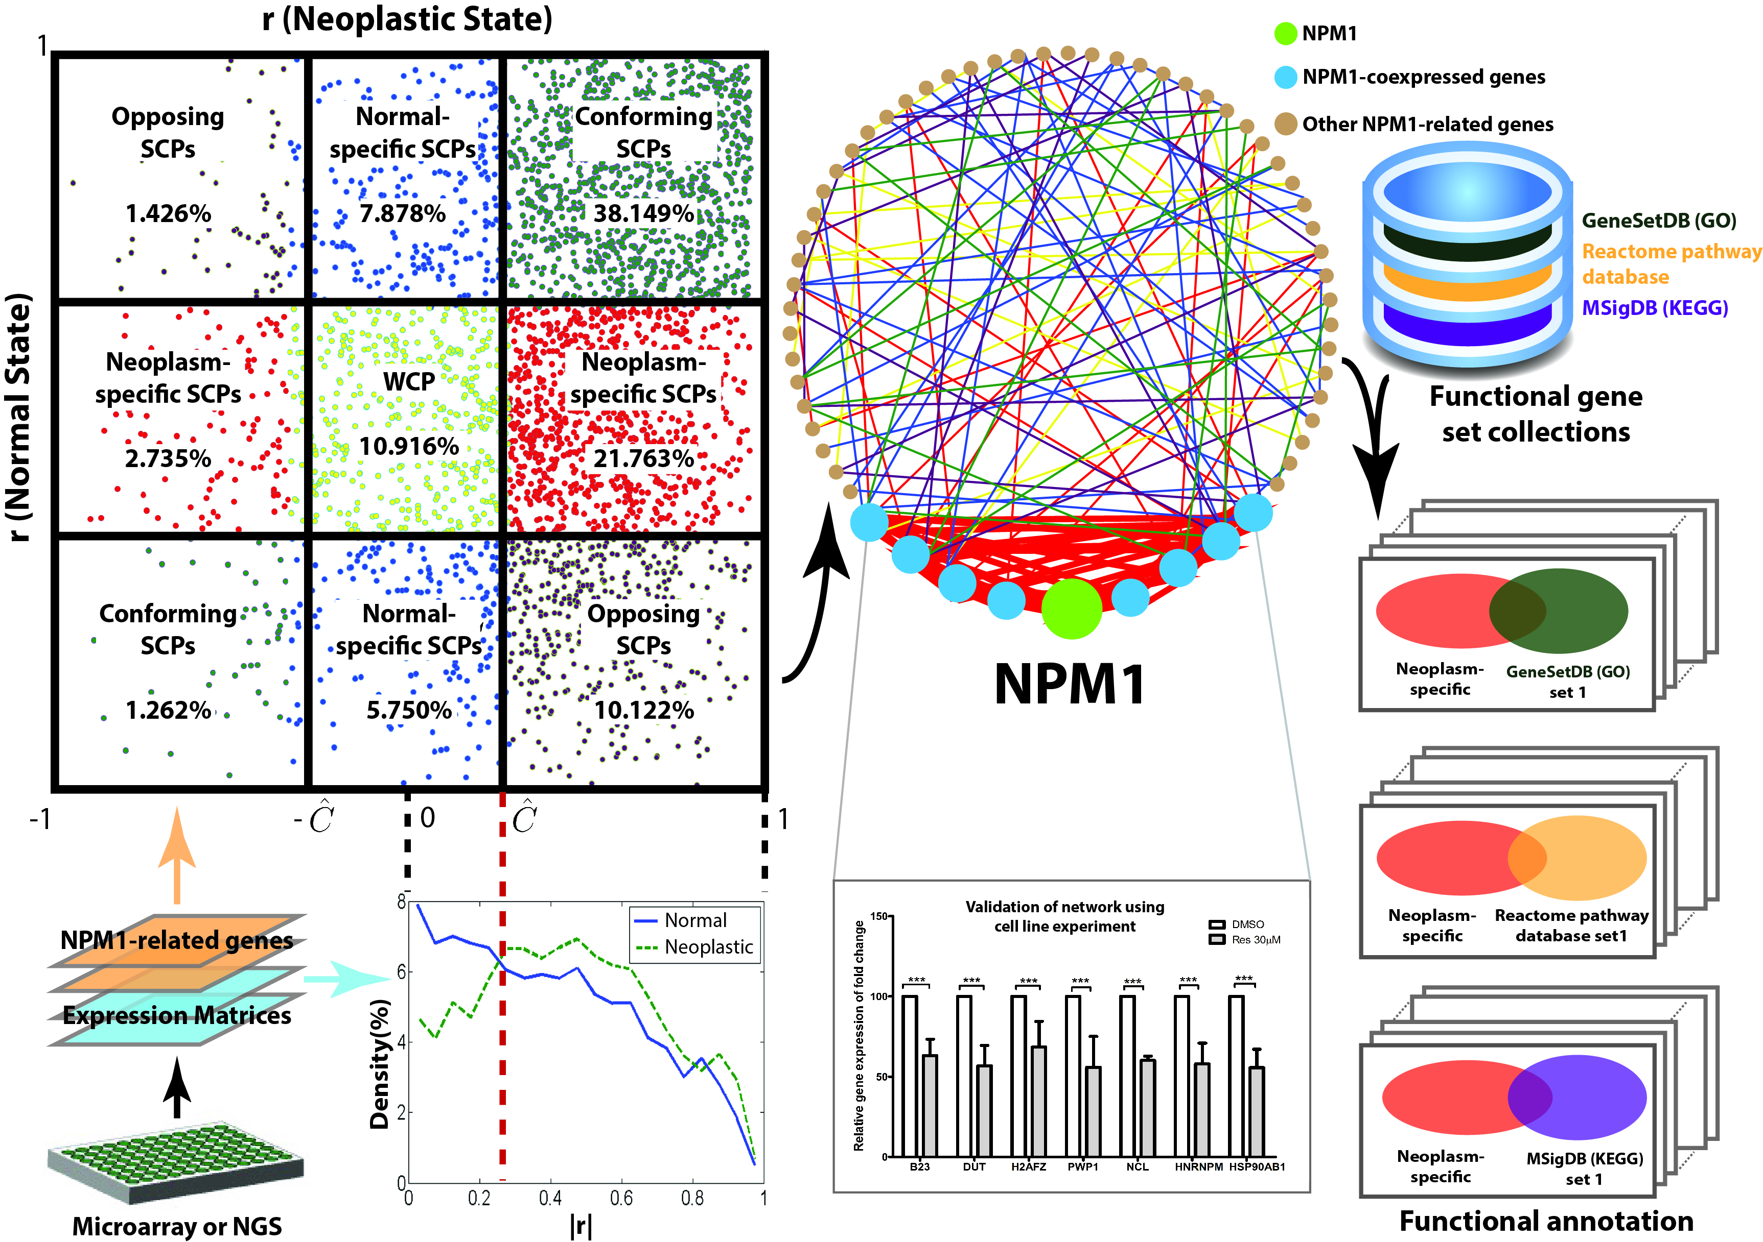

Figure 1. Overview of the proposed strategy, experimental validation and functional annotation analysis. The colours of the points in the co-expression galaxy correspond to those of the lines in the co-expression networks. Red and blue colours represent neoplasm-specific and normal-specific gene pairs respectively. The red ellipse in functional annotation embraces a set of neoplasm-specific gene pairs as its items.

* 1. Dichotomous classification of gene pairs

The determination for linking two genes or not is equivalent to the classification of the gene pair into associated or not. The biological association between two genes is commonly characterized by their co-expression. Based on a co-expression measure, a co-expression level is assigned to each gene pair for each state and its value reflects the relative strength of the gene pair’s biological association amongst the others. The comparison between the co-expression levels of gene pairs in two different states is feasible when a scale-invariant co-expression measure is chosen. The strategy was aimed to determine a co-expression threshold that dichotomizes the gene pairs in strong and weak co-expression classes and optimally differentiates the normal and neoplastic states based on the likelihood of the gene pairs of a state falling into the strong co-expression class over that of the other state.

* + 1. Expression matrices

The proposed strategy is applicable to the expression matrices derived from microarray or RNA-Seq dataset. For RNA-Seq data, the expression of a gene is quantified by “reads per kilobase of exon model per million mapped reads” (RPKM), which normalizes the read measurement by the RNA length and the total read number so as to ensure a fair comparison across samples [26]. For microarray data, the expression level of a gene is measured by one or multiple probes. The raw expression intensities are log transformed and normalized across the samples to ensure the normality of data and that the up and down regulations are equally treated. Average intensity value is taken to represent the expression intensity of a gene measured by multiple probes of microarray chip. A two-dimensional matrix is then formed for each state. Each column of the expression matrix represents the expression profile of a sample across all the considered genes. Each row represents the expression profile of a gene across all the considered samples of the same state. Dimension of the expression matrix is M×N for M genes of interest and N samples of the same state. Throughout this work, the expression level of *i*th gene and *j*th samples is defined as x*ij* and the expression matrix, X, for a state is numerically represented in the following form.

(1)

* + 1. Co-expression measure

As the expression matrices are formed, the expression profiles of genes *i* and *j* can be extracted as [*xi*1, *xi*2, …, *xiN*] and [*xj*1, *xj*2, …, *xjN*] respectively. Co-expression is generally defined as the similarity between the expression profiles. With the assumption of normally distributed expression intensity, Pearson correlation coefficient, *rij*, was selected to measure the co-expression between genes *i* and *j*.

$r_{ij}=\frac{\sum_{k=1}^{N}{\left(x_{ik}-{\overline{x}}_{i}\right)\left(x_{jk}-{\overline{x}}_{j}\right)}}{\sqrt{\sum_{k=1}^{N}{{\left(x_{ik}-{\overline{x}}_{i}\right)}^{2}}}\sqrt{\sum_{k=1}^{N}{{\left(x_{jk}-{\overline{x}}_{j}\right)}^{2}}}}$ (2)

where ${\overline{x}}_{i}=\sum_{k=1}^{N}{x_{ik}/N}$ and ${\overline{x}}_{j}=\sum_{k=1}^{N}{x_{jk}/N}$ represent the mean expression levels of genes *i* and *j* respectively. Considering all possible gene pairs, M×(M-1)/2 correlation coefficients are calculated. For example, in a study considering 20,000 genes, the calculation of 199.99x106 co-expression levels will be required. Sorting and bin counting of such a huge number of co-expression levels make a big challenge in computational load and memory to computing facilities.

* + 1. Traditional pair-wise classification approach

Testing for non-zero correlations is traditional classification approaches, in which parametric statistical tests are performed to gene pairs individually against a predefined significance threshold. To test for non-zero correlation, the correlation coefficient, *r*, was transformed to the statistic $t=r\sqrt{\left(N-2\right)/\left(1-r^{2}\right)}$ and Student’s t-test was performed to assess the statistical significance of correlation. The gene pairs were classified into significantly and not significantly correlated by comparing the *P*-value with the adjusted significance level [27]. The adjustment based on the Bonferroni correction for multiple testing is to divide the predefined significance level, α, by the total number of gene pairs of interest over two states, 2*Q* = M×(M-1) [28]. Thus, the adjusted α is given by α/2Q. However, such approach classifies the gene pairs of the two states independently and doesn’t take into account the contextual difference in co-expression level distributions between neoplastic and normal states.

* + 1. Distribution-based classification approach

Genes, in most of the cases, do not function alone but do interact with the other genes or their products to perform particular functions. The interacting partners of a gene vary with the conditions, such as neoplastic and normal states, and the variation may be genome-wide affecting the interaction patterns of other genes. Thus, the classification should rely on the structural analysis that considers the distributions of co-expression levels and their association with the states to determine a global co-expression threshold for dichotomizing every gene pair.

To classify gene pairs into strong and weak co-expressions, the magnitudes of co-expressions are calculated by taking the absolute values of the Pearson correlation coefficients, given by *C*(*i,j*) = | *rij*|. The co-expression level is denoted by *Cd*(*i,j*) if expression profiles of the *i*th and *j*th genes are extracted from samples of neoplastic state, and *Cn*(*i,j*) if the profiles are extracted from normal state.

To determine a co-expression threshold associated with the states, the approach implicitly test the research hypothesis that the gene co-expression patterns of neoplastic and normal states come from two different distributions. This hypothesis test requires a structural analysis to determine whether the gene pairs in a state more likely exhibit a distribution of stronger co-expression levels than that in the other state. In other words, the coherence of the overall co-expression strength with the state is examined.

Two-sample Kolmogorov-Smirnov (KS) test was applied to analyze the structural difference because it is sensitive to the differences in the distributions of co-expression magnitudes in neoplastic and normal states, *Cd* and *Cn*. Superior to other non-parametric tests, two-sample KS test yields a threshold value, at which the deviation between the cumulative distribution functions of *Cd* and *Cn* is maximal [29]. Let *Fd*, *Fn* and *D* be the cumulative distribution functions (CDF) of *Cd* and *Cn* and the maximum deviation respectively. The value of *D* is given by:

|  |  |
| --- | --- |
|  | (3) |

Note that the inequalities considered in the CDFs are inverted because our interest focuses on the strong co-expression.

|  |  |
| --- | --- |
| $$F_{d}\left(C\right)=Prob\left(C_{d}≥C\right)$$ | (4) |
| $$F_{n}\left(C\right)=Prob\left(C_{n}≥C\right)$$ | (5) |

The optimal threshold represents a co-expression magnitude, at which *Fd* and *Fn* are extremely deviated. The statistic of two-sample KS test is *D*, approximately following Chi-square distribution. Thus, the statistical significance is tested by comparing the *P*-value with the confidence level or comparing *D* with the critical value. Based on the identified optimal threshold, the gene pairs were classified into the strong and weak co-expression classes.

* + 1. Quantification of association between co-expression and state

The optimal threshold dichotomizes the gene pairs into strong and weak co-expression classes. Table 1 illustrates the cross-tabulation of gene pair counts between states and co-expression classes and defines their notations. The numbers of strongly and weakly co-expressed gene pairs in neoplastic state are denoted by Qs,d and Qw,d respectively, while those in normal state, Qs,n and Qw,n.

Table 1. Counts of gene pairs in different co-expression classes and states.

|  |  |  |
| --- | --- | --- |
| Class\State | Normal | Neoplastic |
| Strong co-expression | Qs,n | Qs,d |
| Weak co-expression | Qw,n | Qw,d |

The association between the co-expression classes and the states is quantified by the log odds ratio (log(OR)), as given by the following equation. If the value of log(OR) is positive, the strong co-expression is more associated with neoplastic state. If the value is negative, the strong co-expression is more associated with normal state. There is no difference between two states if the value is zero.

|  |  |
| --- | --- |
|  | (6) |

* + 1. Simulated dataset

The use of real gene expression data is not appropriate for evaluating and comparing the pair-wise and distribution-based classification approaches because of two reasons. First, the ground truth, i.e. the actual co-expression levels in the underlying populations, is unknown in real data that are usually obtained from very few samples. Second, the measured expression intensities are usually noisy and the level of noise contamination is unknown. In contrast, it is advantageous to use simulated data because the virtual expression intensities across a huge number of samples can be simulated with the assumed noise contamination and the predefined ground truth. The expression intensities of a subset of samples were randomly selected from the simulated data for evaluating the two approaches.

Considering M genes, Q=M×(M-1)/2 values of correlation coefficients were assumed with a model distribution for each of the normal and neoplastic states. To simulate the scenario that the gene pairs in normal state more likely exhibit a distribution of stronger co-expression levels than that in the neoplastic state, two different distributions of correlation coefficient with a single crossover were modeled for the normal and neoplastic states respectively. For each state, these correlation coefficients were randomly filled into a correlation matrix, W, in dimension of M×M. Only a valid correlation matrix was considered for data simulation. If W is positive definite, Cholesky decomposition is applied to transform W to an upper diagonal matrix, U, such that W=UTU [30]. If W is not positive definite but only one of its eigenvalues is not positive, it will be corrected by replacing the non-positive eigenvalue with the smallest positive floating point number and then the corrected W will be transformed to U. Correlation matrix having more than one non-positive eigenvalues will not be considered for simulating the expression data.

Computer program generates M series of very long noise sequences, each of which consists of N∞ random numbers in normal distribution with zero mean and unity standard deviation, constituting the noise matrix, R∞. The population expression matrix, X∞, in dimension of M×N∞ is obtained by X∞=UR∞. In practice, only a small number of samples, say N=10, can be collected for each state. Thus, we randomly select N columns of the matrix X∞ to form the simulated expression matrix, X.

As shown in Figure 2, the model distributions of co-expression level assume the constant fraction of gene pairs at nine discrete correlations from 0.1 to 0.9 in normal state and a decreasing fraction at another nine discrete correlations from 0 to 0.8 in neoplastic state. It is obvious that strong co-expression is more associated with normal state. However, selection of high thresholds, say 0.75, cannot classify the gene pairs into patterns that are able to exhibit such differential feature. Table 2 shows the gene pair classification patterns and D-value at co-expression thresholds from 0.05 to 0.95. The crossover of the two distributions at r=0.4 represents the expected threshold, which dichotomizes the gene pairs into strong and weak co-expression classes and also optimally differentiates the two states. Such expected threshold indicates a level of gene expression coordination, above which more genes (pairs) in normal state are able to attain than in neoplastic state. Considering ten virtual genes, i.e. M=10, a total of 45 correlation coefficients were simulated for each state using the above transformation approach and randomly assigned to the 45 possible gene pairs to form the model correlation matrix, W (Figure 3). As the matrix W is not positive definite and has one negative eigenvalue, it is corrected by eigenvalue replacement. The correct W is then transformed to the matrix U. For each state, a noise matrix R∞ was formed by independently generating 10 white noise sequences of 10,000 numbers each and the population expression matrix X∞=UR∞ in dimensions of 10×10,000 was generated. The correlation matrices derived from expression data of 10,000 virtual samples of each state provide the ground truth. The cumulative distribution functions of the correlation coefficient indicate a maximum deviation at r=0.324, giving the expected threshold (Figure 4). This threshold defines the strongly and weakly co-expressed gene pairs as the ground truth (Figure 5). By randomly selecting 10 columns from each population expression matrix, two expression matrices Xd and Xn were simulated for neoplastic and normal states respectively (Figure 6).

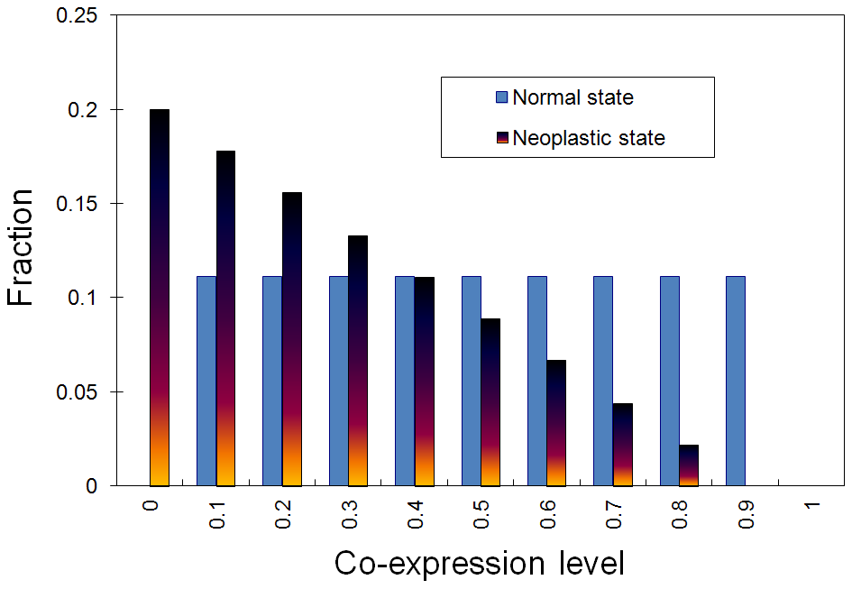

Figure 2. Model distributions of co-expression level: It is assumed that the normal state exhibits a constant fraction of gene pairs at 9 discrete values of correlation coefficient from 0.1 to 0.9 and the neoplastic state, a decreasing fraction at 9 discrete values from 0 to 0.8.

Table 2. Gene pair classification patterns at various thresholds.

|  |  |  |  |  |  |
| --- | --- | --- | --- | --- | --- |
|  | Normal state (fraction) | | Neoplastic state (fraction) | | D-value |
| Threshold | Qs,n / Q | Qw,n / Q | Qs,d / Q | Qw,d / Q | (Qs,n - Qs,d)/Q |
| 0.95 | 0 | 1 | 0 | 1 | 0 |
| 0.85 | 0.111 | 0.889 | 0 | 1 | 0.111 |
| 0.75 | 0.222 | 0.778 | 0.022 | 0.978 | 0.2 |
| 0.65 | 0.333 | 0.667 | 0.067 | 0.933 | 0.267 |
| 0.55 | 0.444 | 0.556 | 0.133 | 0.867 | 0.311 |
| 0.45 | 0.556 | 0.444 | 0.222 | 0.778 | 0.333 |
| 0.35 | 0.667 | 0.333 | 0.333 | 0.667 | 0.333 |
| 0.25 | 0.778 | 0.222 | 0.467 | 0.533 | 0.311 |
| 0.15 | 0.889 | 0.111 | 0.622 | 0.378 | 0.267 |
| 0.05 | 1 | 0 | 0.8 | 0.2 | 0.2 |

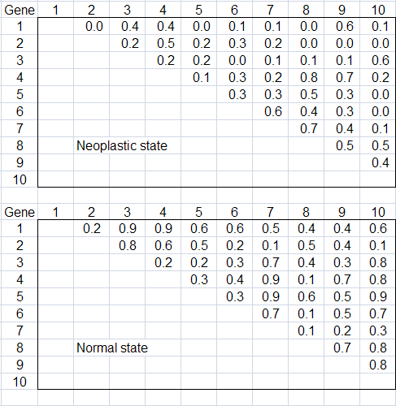

Figure 3. Model correlation matrices: The correlation coefficient values of the two model distributions were randomly assigned to the virtual gene pairs in normal and neoplastic states respectively. Only the off-diagonal elements of the correlation matrices are shown here because the matrices are symmetric over the diagonal.

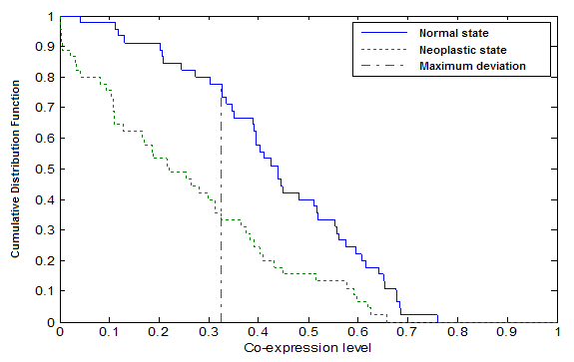

Figure 4. Cumulative distribution functions of co-expression level of 10,000 virtual samples each in normal and neoplastic states respectively: Solid line represents *Fn* and dashed line, *Fd*. Two functions deviate optimally at r=0.324, giving the expected threshold.

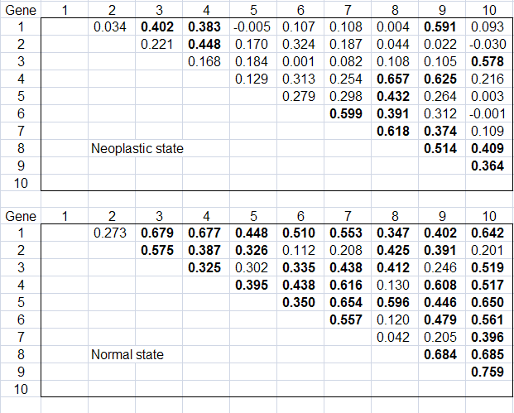

Figure 5. Ground truth: Two correlation matrices were calculated using the simulated expression data of 10,000 virtual samples in normal and neoplastic states respectively. With the expected threshold at r=0.324, the pairs with strong co-expression are defined and highlighted by bold font. Only the off-diagonal elements of the correlation matrices are shown here because the matrices are symmetric over the diagonal.

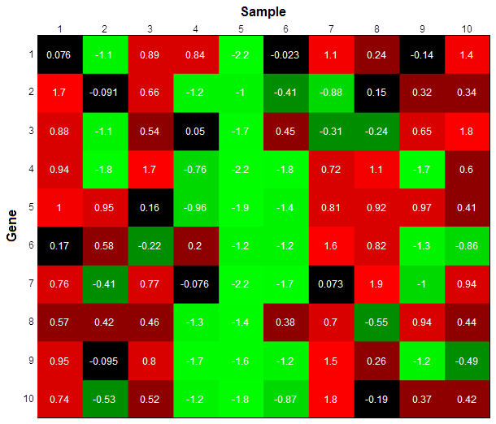

(a) Normal state

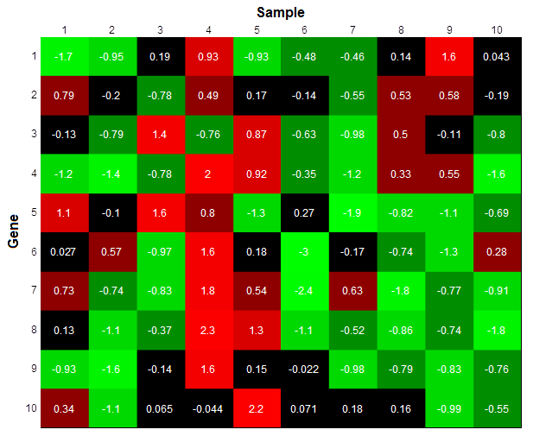

(b) Neoplastic state

Figure 6. Simulated expression matrices: (a) *Xn* for normal state, (b) *Xd* for neoplastic state

* + 1. Evaluation of classification approaches on simulated dataset

Both pair-wise and distribution-based classification approaches can determine a co-expression threshold for dichotomizing the gene pairs into the predicted strong and weak co-expression classes. Using the simulated data, the co-expression classes were predicted and checked against the true strong and weak co-expression classes. Regarding the predicted strongly and weakly co-expressed pairs as positive and negative cases respectively, the true positives, true negatives, false positives and false negatives were counted against their actual classes. The performances of the two approaches were evaluated and compared with respect to the sensitivity, specificity and overall accuracy of prediction given by the following formulas.

(7)

(8)

(9)

* 1. State-associated co-expression analysis

It is intriguing to verify whether the gene pair classes dichotomized by distribution-based approach are associated with the states. If such association exists, the distinct co-expression patterns can be applied to explore the specific, common and opposite characteristics of the neoplastic and normal states. Partitioned by the optimal threshold, the scatter plot of gene pairs against their correlation coefficients of the two states consolidates these state-associated characteristics. The gene networks constructed by gene pairs in these mutually exclusive partitions allow us to decipher the neoplastic disease mechanism in comparison with normal molecular mechanism. The analyses are performed in both genomic scale and gene sets.

* + 1. Real microarray dataset

The microarray dataset, considered for the proof of concept in this work, was generated by a study that analyzed the molecular signature of CD34+ hematopoietic stem/progenitor cells in CML [31]. The study recruited nine untreated newly diagnosed Ph+ CML patients and eight healthy volunteers and collected their bone marrow mononuclear cells. The subjects are all Caucasians who were living in Germany. The CD34+ cells were selected using two rounds of separation and the purities as assessed by flow cytometry ranged from 98.9 to 99.9%. Total RNA was isolated from the cells, labeled and hybridized to Affymetrix HG-Focus GeneChips of 8746 probes interrogating 8537 genes. The dataset was obtained from Gene Expression Omnibus (GEO) under the accession number GSE5550. To ensure the normality of data, the expression intensity measured by each probe is log transformed and normalized across the samples. For probes concerned about the same gene, average intensity value was taken to represent the expression intensity of that particular gene. Two expression matrices of dimensions 8537×9 and 8537×8 were formulated for neoplastic and normal states respectively based on the dataset. Each row of the expression matrix represents the relative expression intensities of a gene across all the samples of the same state while each column represents that of 8537 genes in a particular sample.

* + 1. Relationship between co-expression structures and galaxy

The co-expression structure is defined as the distribution of co-expression levels of a state. The x-axis represents the co-expression levels ranging from 0 to 1 and the y-axis represents the densities of gene pairs co-expressed at these levels. Figure 7 shows a hypothetical example of two co-expression structures whose densities have a breakeven point at |r|=Ĉ. The area of the shaded region represents the maximum deviation, D, between the cumulative distribution functions. The value of D can also be expressed in terms of gene pair counts, as given by the following equation.

|  |  |
| --- | --- |
|  | (10) |

where Q = Qs,d + Qw,d = Qs,n + Qw,n denotes the total number of gene pairs. The value of D ranges from 0 to 1 and measures the difference between two co-expression structures. The value of D becomes zero when two co-expression structures are identical. A D-value significantly different from zero indicates a structural difference in co-expression between the normal and neoplastic states.

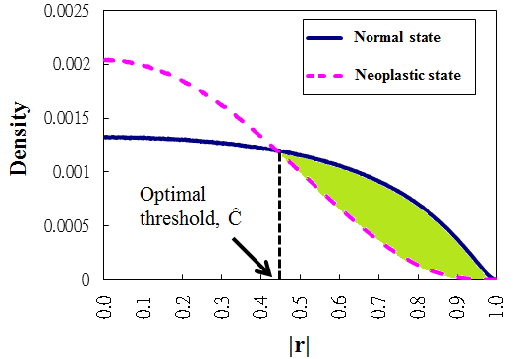

D-value

Figure 7. Two hypothetical co-expression structures of normal and neoplastic states. The area of the shaded region delimited by Ĉ represents the D-value.

Differential co-expression structures imply that the states are associated with and uniquely characterized by their own distinguishable co-expression patterns. Scatter plot of gene pairs with respect to the their correlation coefficients of gene expression levels over the two states facilitates the exploration of such patterns and the identification of gene pairs that uniquely characterize a particular state and contrast between the two states. As shown in Figure 8, such graphical illustration is referred to as a co-expression galaxy where each data point on it represents a gene pair, the y-axis represents the co-expression levels of the normal state and the x-axis represents that of the neoplastic state. Both axes range from -1 to 1. The centre of the co-expression galaxy represents zero correlations in both states.

This work also aims to explain the structural difference in gene co-expression levels between normal and neoplastic states through the regional difference in co-expression galaxy on genomic scale and in specific functional gene sets. With an optimal threshold Ĉ determined by the distribution-based classification approach, the co-expression galaxy is partitioned into nine regions containing normal-specific strongly co-expressed pairs (SCPs), neoplasm-specific SCPs, conforming SCPs and opposing SCPs and weakly co-expressed pairs (WCPs) as shown in Figure 8. A WCP exhibits co-expression levels below the threshold in both states while a SCP exhibits co-expression levels above the threshold in at least one state. Gene expression levels of a conforming SCP are concurrently positively or negatively correlated in both states. The sign of correlation of an opposing SCP in one state is opposite to that in the other state. Genes of a normal-specific SCP are co-expressed strongly in normal state but weakly in neoplastic state. Genes of a neoplasm-specific SCP are co-expressed strongly in neoplastic state but weakly in normal state.

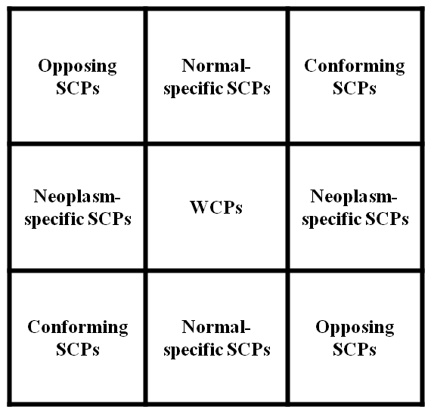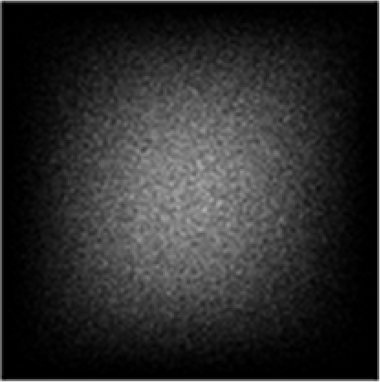

**r (Neoplastic state)**

**r (Normal state)**

**0**

**1**

**1**

**0**

**-1**

**-1**

**r (Neoplastic state)**

**r (Normal state)**

**0**

**1**

**1**

**0**

**-1**

**-1**

Ĉ

Ĉ

-Ĉ

-Ĉ

Figure 8. Co-expression galaxy (left) and nine regions partitioned by optimal threshold Ĉ (right). SCP and WCP stand for strong and weak co-expressed pairs respectively.

It is intriguing to collate the partitioning with the correlation distributions. Figure 9 shows that the strong co-expression tails of the correlation distribution in neoplastic state assemble the neoplasm-specific, conforming and opposing SCPs. Similarly, it is shown in Figure 10 that the strong co-expression tails of the correlation distribution in normal state assemble the normal-specific, conforming and opposing SCPs. According to equation (10), the structural difference is quantified by D-value and is equivalent to the discrepancy in the densities represented by the strong co-expression tails between the two states where the conforming and opposing SCPs are found in common. In other words, the structural difference in co-expression is simply determined by the pair count difference between the normal-specific and neoplasm-specific SCPs. It is also interesting to note that the co-expression galaxy will be asymmetric about the identity line if the counts of normal-specific and neoplasm-specific SCPs are different. Thus, the regional difference in gene pair counts in co-expression galaxy, especially for normal-specific and neoplasm-specific SCPs, accounts for the differential co-expression structures.

Distribution-based gene pair classification was performed to the genome-wide expression matrices derived from the real microarray dataset. To verify the connection of NPM1 with the MAPK and PI3K/AKT pathways in CML, the pairs between NPM1 and the pathway members were extracted from the identified CML-specific and normal-specific SCPs and illustrated graphically for the comparison. The implication of the co-expression galaxy’s regional difference was further investigated through the network analysis of gene pairs in these partitioned regions.

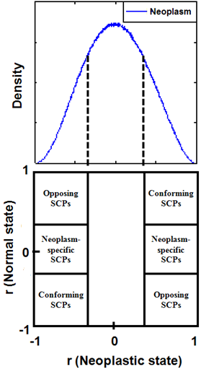

Ĉ

-Ĉ

-Ĉ

Ĉ

Figure 9. Relationship between the strong co-expression tails of distribution in neoplastic state and the six regions in the co-expression galaxy

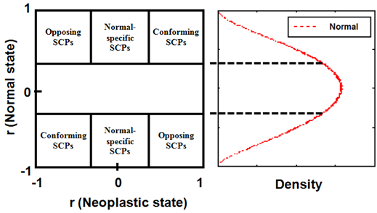

Ĉ

-Ĉ

Ĉ

-Ĉ

Figure 10. Relationship between the strong co-expression tails of distribution in normal state and the six regions in the co-expression galaxy

* 1. NPM1-related co-expression networks

Besides the genome-wide analysis of structural difference in co-expression, another important research question is whether the normal and neoplastic states exhibit different co-expression patterns over a set of genes closely related to a particular physiological function or pathological feature. Following the same distribution-based approach for gene pair classification as derived above, the gene pairs were classified into strongly and weakly co-expressed pairs (SCPs and WCPs) and their associations with normal and neoplastic states were quantified by the value of log(OR). The SCPs specifically found in normal state represent the gene-gene associations, e.g. protein-protein interactions, which maintain the considered physiological function or inhibit the considered pathological feature in normal state but are lost, impaired or bypassed in neoplastic state. The pathologically altered gene-gene associations represented by the neoplasm-specific SCPs indicate the plasticity of the cellular responses to the genetic variations or the external stress.

* + 1. NPM1-related genes

According to the gene list curated by Brentani et al. [32], NPM1 is one of 380 cancer-associated genes. Using the global cancer map compendium derived by the multiclass clustering of tumor gene expression data [33], a set of NPM1-associated genes was identified with the criteria that the gene neighborhoods at a Pearson correlation not less than 0.8 were included and the set contains no fewer than 25 genes [34]. Note that such pre-defined threshold was not applied to the classification approach proposed by this study. Consisting of 116 genes including NPM1, the NPM1-associated gene set (GCM\_NPM1) is stored as one of the gene sets in the Molecular Signature Database (MSigDB) [34]. As 93 of 116 genes can be found in the real microarray dataset considered in this work, the expression profiles of these 93 genes were extracted from the expression matrix mentioned above for the co-expression analysis of the NPM1-associated gene set. The reduced expression matrix is in dimension of 93x17 where each row represents the relative expression intensities of a gene across the 8 normal and 9 CML samples. The co-expression levels of 4278 possible gene pairs were computed for each of the normal and CML states.

* + 1. Significance test of observed co-expression pattern

To test if the observed co-expression pattern is not obtained by chance, the value of log(OR) that characterizes the observed pattern was compared with the null distribution of log(OR) generated by randomization. In each randomization process, 93 genes (the same number as NPM1-related gene set) were randomly selected from 8537 genes that were considered in the real microarray dataset and a reduced expression matrix was formed based on these 93 randomly selected genes. The same co-expression analysis was performed to the randomly reduced expression matrix so as to obtain the cross-tabulation of gene pair counts between states and co-expression classes and thus calculate a value of log(OR). The process was repeated for 1000 times to generate the null distribution of log(OR) due to randomization and create a histogram of such distribution. The p-value indicating the significance was estimated using the area under the curve of the left or right tail of the null distribution delimited by the value of log(OR) of the observed pattern.

* + 1. Network analysis

Using the same approach as the genome-wide analysis, the co-expression galaxy of NPM1-associated gene set was also partitioned into normal-specific, neoplasm-specific, conforming and opposing SCPs and WCPs. The gene networks of normal-specific and CML-specific SCPs were constructed to visualize and explain the mechanisms underlying neoplastic pathology and normal physiology related to NPM1. The visualization of these gene networks focused on the connections between NPM1 and its strongly co-expressed genes and those among the RP genes to elucidate the altered association of NPM1 with ribosome biogenesis in CML.

To visualize the gene networks, we used nodes to represent individual genes and edges between nodes to indicate that the gene pairs are strongly correlated. The edge thickness was proportional to the level of differential co-expression, which is quantified by the Z statistic given by the following formula. [35]

$Z=\frac{\left|z_{d}-z_{n}\right|}{σ}$ (11)

where *zd* and *zn* are the Fisher-transforms of *r* over CML and normal groups respectively,

$z=\frac{1}{2}\ln\left|\frac{1+r}{1-r}\right|$ (12)

and σ is given by

$σ=\sqrt{\frac{1}{N_{d}-3}+\frac{1}{N_{n}-3}}$ (13)

where *Nd* and *Nn* represent sample numbers in CML and normal groups respectively. The identified connections were validated by cell line experiment and their underlying mechanisms were elucidated using the functional annotation analysis.

* 1. Validation of networks using cell line experiment

Based on the above co-expression network analysis of gene pairs, gene pairs were divided into normal-specific, CML-specific, opposing and conforming classes. We focused on NPM1/B23-centered connections in the CML-specific network and further investigated the gene pairs’ expression levels in CML cells under Resveratrol treatment, which is potent anti-inflammatory agent and applied in anti-cancer treatment with other therapeutic anti-cancer drugs [36, 37].

* + 1. Cell lines and treatment

K562 cells, human CML cell line, were grown in RPMI1640 medium supplemented 10% fetal bovine serum. Cultures were incubated at 37 °C in 5% CO2. To validate the co-expression network, K562 cells were treated for 24 hrs with 30 μM Resveratrol (Res) or with DMSO as a vehicle control. Then, the K562 cells were collected and harvested for total RNA extraction.

* + 1. RNA isolation and reverse transcription-PCR (RT-PCR)

Total RNA was isolated from control- or Res-treated K562 cells using the Trizol Reagent (Life Technologies) according to manufactory’s protocol. Following RNA extraction, 2μg of total RNA was reverse-transcribed cDNA with oligo (dT) 15 using M-MLV reverse transcriptase (Life Technologies) in a total volume of 20μL reactive volume. After reverse transcription reaction, each cDNA samples were diluted by DEPC-treated H2O in a final volume of 40μL/sample and stored at -20°C or immediately used for Real-time PCR.

* + 1. Real-time PCR

Twenty-one genes, which were found strongly co-expressed with NPM1/B23 in CML-specific network, were selected for validation of co-expression network upon resveratrol treatment in CML. Real-time PCR was performed using MaximaTM SYBR Green/ROX qPCR Master Mix (Fermantas) and ABI Prism 7500 system (Applied Biosystems). The primer sequences using in Real-time PCR are listed in Table 3. Triplicate PCRs were performed. All the data were analyzed after normalizing to β-actin expression values of the respective sample, and the expression levels are presented by the mean ±SD of at least three independent experiments.

Table 3. Sequences of primers used for Real-time PCR.

|  |  |
| --- | --- |
| **Gene** | **Primer sequence** |
| SUMO2 | 5’-GTTTTCCCTTCAAGTCAAGC-3’ |
| 5’-GTTACTTCTAAGCAGGCCTAT-3’ |
| DUT | 5’-ACCTATGGAGAAAGCTGTT-3’ |
| 5’-TAAAGTGTTTTGCAGCCAAG-3’ |
| TCP1 | 5’-GCTCGGGTACGCTCCAC-3’ |
| 5’-CCATCTTGACGGCAGCGATA-3’ |
| NONO | 5’-ACAGGGCCGTGTAGC-3’ |
| 5’-CATTTTTGCACCCTCAACTT-3’ |
| PSMB4 | 5’-TTTCAAACCGCCACTGTCAC-3’ |
| 5’-TGGGCAATATCCCAGTTGGT-3’ |
| PSMA5 | 5’-GGACCTTTGTACAGTGTGAT-3’ |
| 5-‘GCTTCTCCTCCATTACTTGT-3’ |
| PSMA2 | 5’-CTTAATGCCCTCTTCGCTAT-3’ |
| 5’-TTCCATGAATCCGTGAAAGT-3’ |
| PPP1CC | 5’-AGAAGCCAAATGCCACGAGA-3’ |
| 5’-TCACGACTAGGCAGTGTCAA-3’ |
| PWP1 | 5’-GATTCAGTGGGCAGATAGAG-3’ |
| 5’-TATCTGAACGTGCATCCAAA-3’ |
| NCL | 5’-GGACAGTAAGAAAGAGCGAG-3’ |
| 5’-GCTGACTAATCTGATCTCCG-3’ |
| KHDRBS1 | 5’-AGGATTCCTGTTGCTTTACC-3’ |
| 5’-AAGAATGGAATAAGGTGGGG-3’ |
| HSP90AB1 | 5’-AAAGCACAACGATGATGAAC-3’ |
| 5’-TTCACTACTTCTTTGACCCG-3’ |
| HNRNPM | 5’-TGAGAAATCTGCCATTCGAT-3’ |
| 5’-ATTCTCCATCTTGATGTCGG-3’ |
| H2AFZ | 5’-CTTGCTATTCGTGGAGATGA-3’ |
| 5’-TCCCAATCAGAGATTTGTGG-3’ |
| SRSF9 | 5’-TACCAGGGCCATATTAGCA-3’ |
| 5’-CTCCATAGTAGAGCGAACCC-3’ |
| APEX1 | 5’-AAAATATTGCTTCGGTGGGT-3’ |
| 5’-CTTACTCTTCTTGGCCTCTG-3’ |
| RABGGTB | 5’-TCCTAAGTCTACCCAGGAAC-3’ |
| 5’-CAATAACAAAGTGTCCGGTG-3’ |
| TAF9 | 5’-CCATCATTAATCGGGTCCAA-3’ |
| 5’-ACATTCAGCAAGGCTAGATT-3’ |
| RPL36A | 5’-AAGATTGTGCTAAGGCTTGA-3’ |
| 5’-TTAGAACTGGATCACTTGGC-3’ |
| RPL31 | 5’-CCGAGAATACACCATCAACA-3’ |
| 5’-CGGTATGGCACATTCCTTAT-3’ |
| RPL10A | 5’-ATGAGGTGAAGTCCACAATC-3’ |
| 5’-TGATATATAAGGCCCGGACA-3’ |
| NPM1/B23 | 5’-AAGGTGAATCGAGGTGCTCT-3’ |
| 5’-CTGTGTAAGATATGGCGGGTT-3’ |
| β-actin | 5’-AGAAAATCTGGCACCACACC-3’ |
| 5’-CCATCTCTTGCTCGAAGTCC-3’ |

* 1. Functional annotation analysis

The co-expression network analysis of NPM1-related genes identified five mutually exclusive networks, including the CML-specific, opposing, normal-specific, conforming, and weak co-expression networks. In order to elucidate the functional roles and pathways of these networks, functional annotation analysis was performed on these networks using three collections of predefined functional gene sets. The three collections are GeneSetDB [38], Reactome pathway database [39], and Molecular Signatures Database (MSigDB, v3.0) [34], providing 2,431 Gene Ontology (GO) sets [40], 1,345 Reactome pathways (as of Oct 12, 2012) and 186 KEGG pathways [41] respectively.

Conventional gene set analysis regards single genes as basic items for mapping between the experimentally identified genes and a functional gene set [42]. However, the basic items of co-expression network are gene pairs and the conventional approach cannot address the connectivity of genes through the mapping of individual genes. We developed a pair-based mapping approach for the functional annotation of the identified networks. A gene pair in the identified network will be mapped onto a functional gene set if both genes of the pair are found in the gene set. After the pair-based mapping, a two-by-two contingency table is formed (Table 4). The gene pairs are classified in two aspects. One aspect is to classify whether they are found or not found in a gene set. The other aspect is to classify if they are gene pairs of a particular network or those of the other four networks. In the table, *H* is the total number of all possible gene pairs, *h* is the number of gene pairs of a particular network, *K* is the number of gene pairs found in a functional gene set, and *k* is the number of gene pairs of the network and also found in the functional gene set. After the observed outcomes of the contingency table were counted, two-tailed Fisher's exact test [43] based on the hyper-geometric distribution was performed to determine whether the gene pairs of a network are significantly associated to the gene set.

Table 4. Two-by-two contingency table for gene pairs of a particular network and gene pairs of other networks in a function gene set.

|  |  |  |  |
| --- | --- | --- | --- |
|  | Gene pairs of a network | Gene pairs of other networks | Total |
| In gene set | *k* | *K-k* | *K* |
| Not in gene set | *h-k* | *(H-K)-(h-k)* | *H-K* |
| Total | *h* | *H-h* | *H* |

In the test, the null hypothesis assumes that the network and the functional gene set are independent. Based on the hyper-geometric distribution, the probability *pk* of the observed outcomes of a 2×2 table is calculated as:

|  |  |
| --- | --- |
| $$p_{k}=\frac{\left(\begin{matrix}K \\ k\end{matrix}\right)\left(\begin{matrix}H-K \\ h-k\end{matrix}\right)}{\left(\begin{matrix}H \\ h\end{matrix}\right)}$$ | (14) |

The totals along rows and columns, i.e. *K, H-K, h* and *H-h* in Table 4, are known as marginal totals. With the same marginal totals, there may be some other possible combinations of the four entries in the contingency table and each combination is accompanied with a probability *pi* given by (14). By fixing the marginal totals as those of the observed outcomes, the *p*-value for testing the null hypothesis was calculated by summing the probabilities of combinations, *pi*’s, that are less than or equal to the probability *pk* of the observed outcomes [44-46]. The formula for *p*-value is defined by (15).

|  |  |
| --- | --- |
| $$p=\sum_{i=0,…,H}{p_{i}} where p_{i}=\frac{\left(\begin{matrix}K \\ i\end{matrix}\right)\left(\begin{matrix}H-K \\ h-i\end{matrix}\right)}{\left(\begin{matrix}H \\ h\end{matrix}\right)} and p_{i}≤p_{k}$$ | (15) |

The *p*-values were computed for all possible mappings between the five identified networks and the functional gene sets. Functional gene sets without any gene pair found in the identified networks (i.e. *k*=0) were excluded for the test because of lack of information for evaluating their associations with the networks. The computed *p*-values were then adjusted for multiple testing using the Benjamini and Hochberg’s method [10] and the Bonferroni correction [47]. The adjustment was performed independently for different networks and different gene set collections.

The Fisher’s exact test examines the significance of the association between a network and a functional gene set only. However, to further determine whether the network is over-represented or under-represented in the functional gene set, we need to compare the observed number of gene pairs of the network found in the functional gene set, *k*, with its expected value, *ke*. Under the independence assumption of the null hypothesis, *ke* can be estimated using the marginal totals in the contingency table (Table 4) as follow.

|  |  |
| --- | --- |
| $$k_{e}=\frac{hK}{H}$$ | (16) |

If *k* is greater than *ke*, the over-representation is indicated. Inversely, the under-representation is indicated.

1. Results
   1. Performances of classification approaches on simulated dataset

Ten samples were randomly chosen from 10,000 virtual samples for each state. As ten virtual genes were considered, a 10×10 empirical expression matrix was extracted from the population expression matrix for each state, mimicking the practical situation of small number of samples. Forty-five correlation coefficients were then calculated for each state (Figure 11).

|  |  |  |  |  |  |  |  |  |  |  |
| --- | --- | --- | --- | --- | --- | --- | --- | --- | --- | --- |
| Gene | 1 | 2 | 3 | 4 | 5 | 6 | 7 | 8 | 9 | 10 |
| 1 |  | 0.092 | 0.015 | **0.521** | -0.102 | -0.059 | -0.064 | 0.056 | **0.356** | -0.418 |
| 2 |  |  | -0.049 | **0.503** | 0.003 | 0.179 | 0.236 | 0.355 | 0.143 | 0.062 |
| 3 |  |  |  | 0.206 | 0.256 | -0.193 | -0.142 | 0.183 | 0.113 | **0.493** |
| 4 |  |  |  |  | -0.011 | 0.171 | 0.339 | **0.763** | **0.778** | 0.330 |
| 5 |  |  |  |  |  | 0.003 | 0.044 | 0.209 | 0.336 | -0.130 |
| 6 |  |  |  |  |  |  | **0.783** | **0.502** | 0.200 | 0.058 |
| 7 |  |  |  |  |  |  |  | **0.782** | **0.420** | 0.301 |
| 8 |  | Neoplastic state | | |  |  |  |  | **0.779** | **0.554** |
| 9 |  |  |  |  |  |  |  |  |  | **0.372** |
| 10 |  |  |  |  |  |  |  |  |  |  |
|  |  |  |  |  |  |  |  |  |  |  |
| Gene | 1 | 2 | 3 | 4 | 5 | 6 | 7 | 8 | 9 | 10 |
| 1 |  | 0.195 | **0.756** | **0.712** | **0.363** | 0.307 | **0.655** | **0.363** | **0.408** | **0.638** |
| 2 |  |  | **0.580** | **0.499** | **0.610** | -0.073 | **0.509** | **0.578** | **0.472** | **0.460** |
| 3 |  |  |  | **0.480** | 0.328 | -0.240 | **0.451** | **0.534** | 0.154 | **0.490** |
| 4 |  |  |  |  | **0.497** | **0.498** | **0.873** | 0.245 | **0.766** | **0.668** |
| 5 |  |  |  |  |  | **0.502** | **0.676** | **0.661** | **0.675** | **0.763** |
| 6 |  |  |  |  |  |  | **0.563** | 0.042 | **0.710** | **0.474** |
| 7 |  |  |  |  |  |  |  | 0.186 | **0.629** | **0.541** |
| 8 |  | Normal state | |  |  |  |  |  | **0.537** | **0.768** |
| 9 |  |  |  |  |  |  |  |  |  | **0.821** |
| 10 |  |  |  |  |  |  |  |  |  |  |

Figure 11. Non-redundant correlation coefficients calculated. Underlined coefficients represent strongly co-expressed gene pairs identified by pair-wise classification. Bold coefficients represent strongly co-expressed gene pairs identified by distribution-based classification.

The pair-wise classification approach identified strongly co-expressed gene pairs whose correlation coefficients were significantly different from zero with a significance level of 0.05 and the adjusted significance level of 5.56×10-4. Without the adjustment of significance level, nineteen gene pairs were predicted to be strongly co-expressed and 71, weakly co-expressed. When the identified gene pairs were checked against those classified by the expected threshold shown in Figure 5, the sensitivity, specificity and overall accuracy were 38%, 100% and 65.56% respectively. With the adjustment, no gene pair was predicted to be strongly co-expressed and the sensitivity, specificity and overall accuracy were 0%, 100% and 44.44% respectively.

The distribution-based classification approach identified an optimal threshold at Ĉ = 0.356. Two distributions were significantly different with *D*=0.511 (*p*=7.63×10-6). Forty-nine gene pairs were classified as strongly co-expressed and 41, weakly co-expressed. The value of log(OR), -0.993, represents an association of strong co-expression with the normal state and complies with that simulated by the model distributions. The sensitivity, specificity and overall accuracy are 92%, 92.5% and 92.2% respectively. The results showed that the distribution-based classification clearly outperformed the pair-wise classification in sensitivity and accuracy. The specificity of the distribution-based classification was lower than but comparable to that of pair-wise classification.

* 1. Genome-wide co-expression structures and galaxy

All genes of the real microarray dataset were considered to form the genome-wide expression matrices for the CML and normal groups. Distribution-based classification was performed on the expression matrices to identify the optimal threshold at Ĉ = 0.3995. The co-expression structures of CML and normal groups are shown in Figure 12. The two curves intersect at the optimal threshold Ĉ and the area enclosed by the two curves between Ĉ and 1 represents the D-value obtained by two-sample KS test where D = 0.0407 (p < 0.001). The strongly and weakly co-expressed gene pairs classified by the optimal threshold were counted for CML and normal groups individually. Table 5 shows the cross-tabulation of the gene pair counts in the four categories. The value of log(OR) is -0.5656, indicating that the strong co-expression of gene pairs is more associated with the normal group.

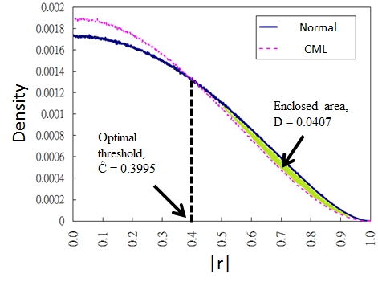

Figure 12. Genome-wide co-expression structures of normal (solid) and CML (dotted) groups. The crossover point indicates the optimal threshold at Ĉ = 0.3995. The shaded area enclosed by the two distribution curves represents the D statistic of two-sample KS test where D = 0.0407 (p < 0.001).

Table 5. Cross-tabulation of gene pair counts in genome-wide analysis.

|  |  |  |
| --- | --- | --- |
| **Class\State**  **(million pairs)** | **CML** | **Normal** |
| **Strong**  **co-expression** | 11.757 | 23.198 |
| **Weak**  **co-expression** | 24.679 | 13.238 |

The two-sample KS test result identified significant difference between the two co-expression structures. To account for the differential structure, the co-expression galaxy was constructed on genomic scale and partitioned into nine regions according to the optimal threshold. Figure 13 illustrates the relationship between the co-expression structures and the nine partitions. The area under the tails of CML co-expression structure was accounted by the sum of the percentages of CML-specific, opposing and conforming SCPs, that is 32.268%, while that of normal co-expression structure, by the sum of normal-specific, opposing and conforming SCPs, that is 36.333%. The difference between the two areas, 4.07%, is exactly the D-value obtained by two-sample KS test and simply the difference between the percentages of normal-specific and CML-specific gene pairs. Such relationship spotlights the importance of contrasting the normal-specific and CML-specific gene pairs. Further, the differential structure implicated the asymmetry of contour map of co-expression galaxy over the identity line as shown in Figure 14.

To verify the connections between NPM1 and BCR-ABL-related pathways in CML, the pairs were formed between NPM1 and the MAPK and PI3K/AKT pathway members and extracted from normal-specific and CML-specific SCPs. Figure 15 illustrates the normal-specific (left, dashed) and CML-specific (right, solid) connections of pathway members with NPM1. It was found that NPM1 exhibited more connections with BCR-ABL-related pathways over the CML state than the normal state. The findings confirmed the role of NPM1 as a nucleolar stress sensor responding to signals transmitted from BCR-ABL-related pathways and elucidated the altered connectivity of the sensory network in CML. It is worthy to note that more BCR-ABL-related pathway members associated with NPM1 in CML disaccord with stronger genome-wide co-expression in normal state. Such observation motivates further co-expression analysis of NPM1-related genes.

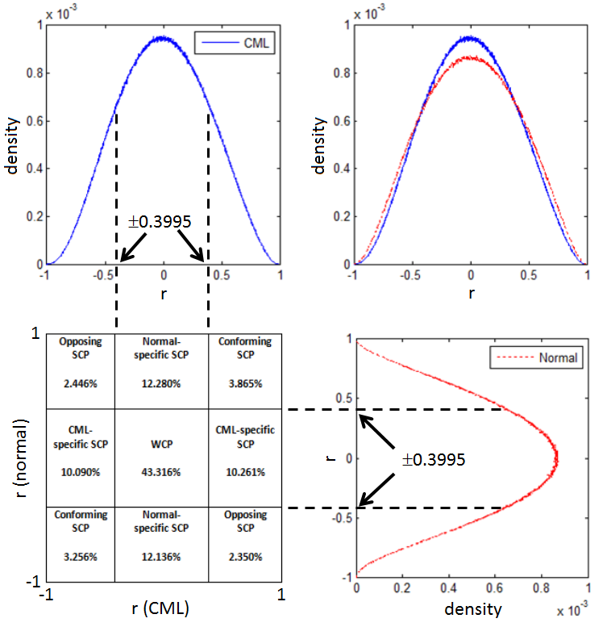

Figure 13. Relationship between co-expression structures and partitioned co-expression galaxy. The partitioning of the co-expression galaxy reveals regional differences in the percentages of gene pairs among nine regions (left-bottom). The combinations of SCP counts accounts for the tails of co-expression structures (left-top, right-bottom). As the genome-wide co-expression structures are most likely symmetric, the difference in the areas under the tails between CML and normal groups is the only cause of differential structure (right-top).

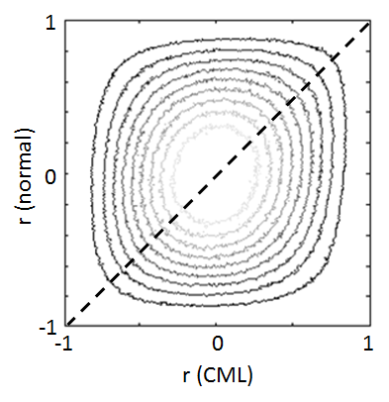

Figure 14. Contour map of co-expression galaxy. Each contour represents a curve tracing points with equal densities over the co-expression galaxy. Dashed line is the identity line where the correlations are equal between normal and CML groups. The contours were not symmetric over the identity line and the asymmetry was attributed by the differential co-expression.

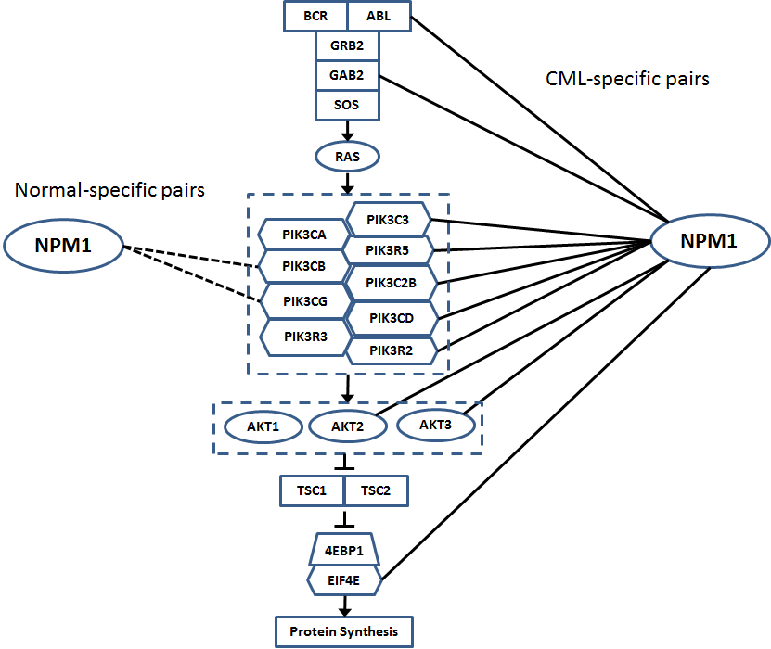

Figure 15. BCR-ABL related pathways (MAPK and PI3K/AKT) and their connections with NPM1. CML-specific pairs and normal-specific pairs are represented by solid lines on the right and dashed lines on the left respectively.

* 1. Co-expression networks for NPM1-related genes

Distribution-based classification was performed on the expression matrices of the NPM1-related genes. The co-expression structures of CML and normal groups are shown in Figure 16. Two-sample KS test identified the optimal threshold at Ĉ = 0.252 and the optimal deviation at D = 0.1087 (p < 0.001). Table 6 shows the 2×2 cross-tabulation of the gene pair counts against co-expression class and group. The corresponding log(OR) value was 0.227, indicating that the strong co-expression of NPM1-related gene pairs was more associated with the CML group. Similar to what was illustrated in Figure 15, the differential structure of NPM1-related genes was opposite to that of the whole genome.

The significance of the observed co-expression pattern was examined by randomization test, which generated the null distribution of log(OR) as shown in Figure 17. A vast majority of randomizations gave negative values of log(OR) and the observed value was at the far right hand side of the null distribution with p=0. Thus, the co-expression pattern was not observed by chance.

Based on the optimal threshold, the co-expression galaxy was partitioned into nine regions and the corresponding percentages of gene pairs are shown in Figure 18. The distribution-based gene pair classification yielded 583 normal-specific and 1048 CML-specific SCPs. The connections between NPM1 and its strongly co-expressed genes and those among RP genes were selected to be visualized in the normal-specific and CML-specific gene networks as shown in Figures 19 and 20 respectively. The normal-specific network consists of two dissociated small sub-networks. One sub-network shows the simple connections among six RP genes and the other connects NPM1 to its six strongly co-expressed genes. In the CML-specific network, NPM1 is connected to its 21 strongly co-expressed genes, in which three are RP genes: RPL10A, RPL31 and RPL36A. These three RP genes are part of a big network connecting 26 strongly co-expressed RP genes. It is clearly shown that the links between NPM1 and RP genes are established and the co-expressions among RP genes become stronger in CML.

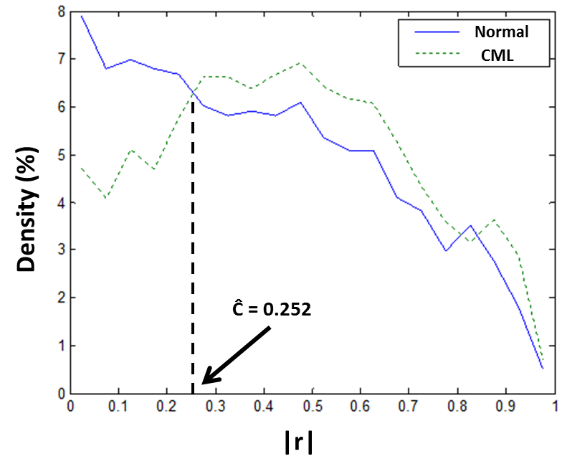

Figure 16. NPM1-related co-expression structures of normal (solid) and CML (dotted) groups. The crossover point indicates the optimal threshold at Ĉ = 0.252.

Table 6. Cross-tabulation of gene pair counts in NPM1-related co-expression analysis.

|  |  |  |
| --- | --- | --- |
| **Class\State** | **CML** | **Normal** |
| **Strong**  **co-expression** | 3228 | 2763 |
| **Weak**  **co-expression** | 1050 | 1515 |

Figure 17. Null distribution of log(OR) against the observed value.

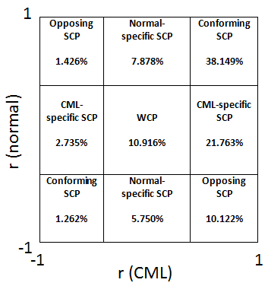

Figure 18. Partitioning of co-expression galaxy of NPM1-related genes.

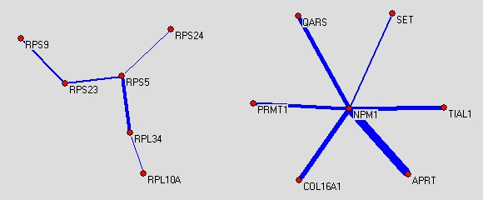

Figure 19. Normal-specific network of NPM1, RP genes and genes strongly co-expressed with NPM1.

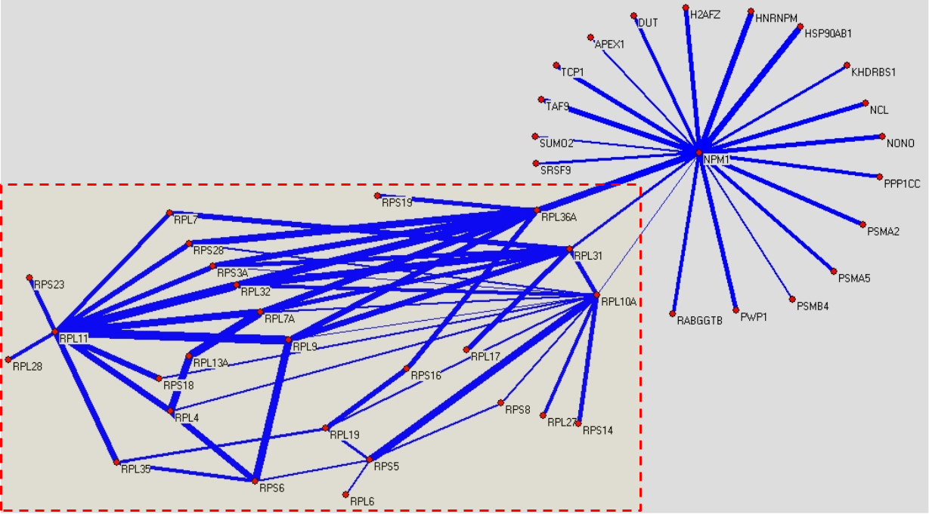

Figure 20. CML-specific network of NPM1, RP genes and genes strongly co-expressed with NPM1. A sub-network of RP genes is shown in the dashed block.

* 1. Cell line experimental validation results

According to gene co-expression network, we identified that there were twenty-one genes strongly co-expressed with NPM1/B23 in CML-specific group. To further validate the accuracy of gene co-expression network, real-time PCR was carried out to examine the co-expression profile of NPM1/B23 associated genes in the K562 cells treated with resveratrol. Compared with the vehicle control (DMSO), we found that the mRNA level of NPM1/B23 was decreased in the presence of resveratrol. Other NPM1/B23 co-expressed genes showed positive correlation patterns during resveratrol treatment (Figure 21). This observation indicated the simultaneous resveratrol-mediated transcriptional repression of these genes that was predicted by the co-expression network.

(A)

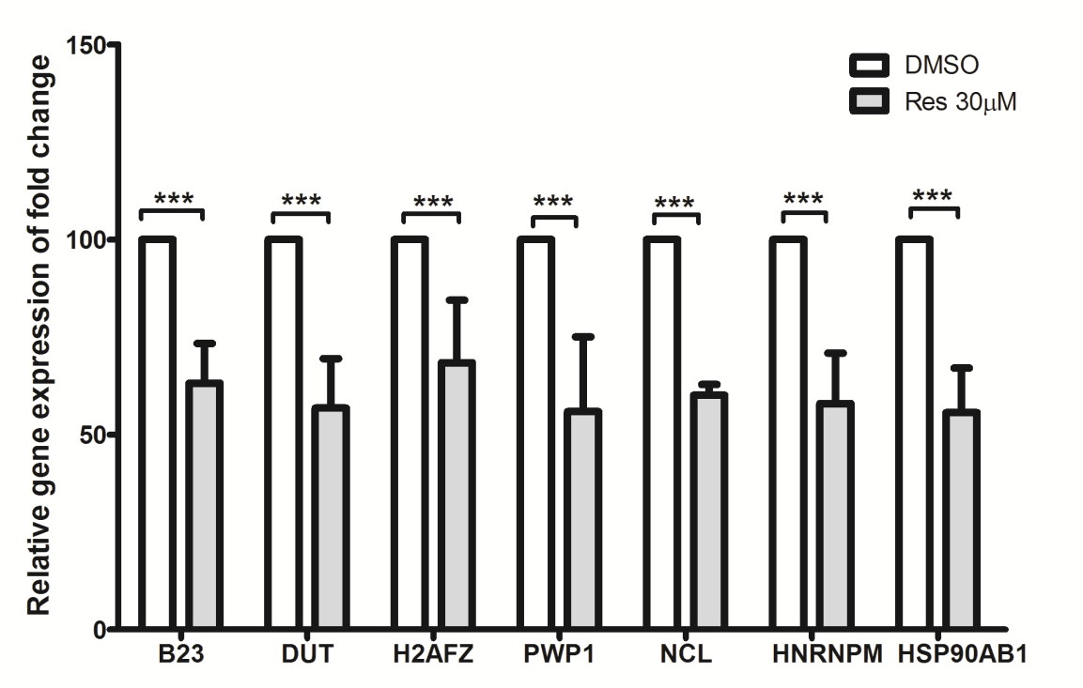

(B)

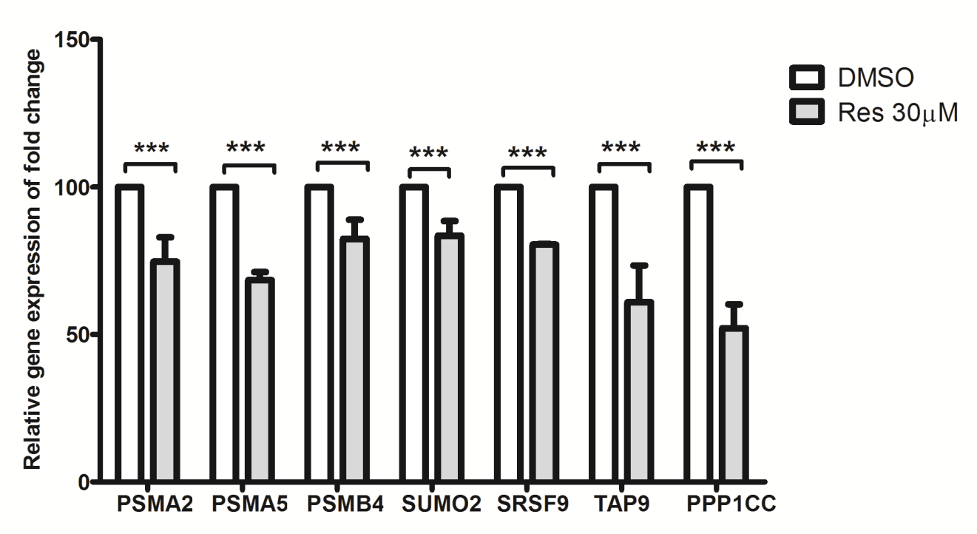

(C)

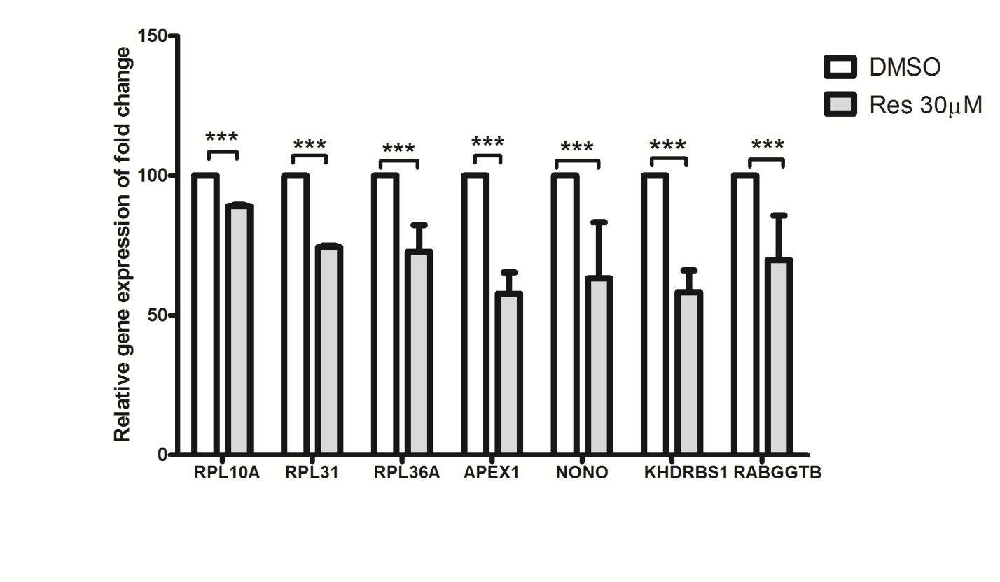

Figure 21. The expression levels of NPM1/B23 and its associated genes during resveratrol treatment. K562 cells were treated with 30 μM resveratrol (Res) or DMSO as control for 24 h. The mRNA levels of the specified genes co-expressed with NPM1/B23 were measured and quantitated by Real-time PCR (see Methods). There were total twenty-one genes strongly co-expressed with NPM1/B23. The relative gene expressions of fold change are respectively shown in (A)-(C). The bar graph is shown with the normalized values in the DMSO-treated cells represented as 100, and with the mean ±S.D. values from three independent experiments.

* 1. Functional annotation results

Functional annotation analysis of the five identified mutually exclusive networks of NPM1-related genes yielded 20, 25 and 2 functional gene set annotations from GeneSetDB (GO), Reactome pathway database and MSigDB (KEGG) respectively. Based on the Fisher’s exact test of the pair-based mapping, each of these 47 annotations showed significant associations with at least one identified networks (Bonferroni adjusted p-value<0.05). The detailed information of these annotations in the three databases and the corresponding statistical data with the networks are shown in Tables S1, S2, and S3 respectively. By comparing the observed and expected numbers of gene pairs in common between the identified networks and the functional gene sets, it was found that the significantly associated functional annotations under-represented the CML-specific, normal-specific, opposing, and weak co-expression networks but over-represented the conforming network.

In MSigDB, the “KEGG Ribosome” was the only gene set annotation that was significantly associated with all the five networks. Gene pairs that were in common between CML-specific network and the “KEGG Ribosome” gene set were identified to construct a ribosome gene network shown in Figure 22. The network consists of 25 genes with 47 connections. Each gene is represented by a circle whose size is proportional to its connectivity with the other genes. Top four hub genes, RPL10A, RPL11, RPL31, and RPL36A, were identified based on their high connectivity with the other genes. According to Figure 20, RPL10A, RPL31, and RPL36A of these top hub genes was strongly co-expressed with NPM1 in CML. Differential expression analysis using t-test was performed to compare the expression levels of these four hub genes in CML with normal groups. It was shown that two NPM1-coexpressed hub genes, RPL10A (p=0.227), and RPL31 (p=0.174), were not significantly under- or over-expressed but another NPM1-coexpressed hub gene, RPL36A (fold change=0.90, p=0.048), and the non-NPM1-coexpressed hub gene, RPL11 (fold change=0.88, p=0.027), were significantly under-expressed in CML.

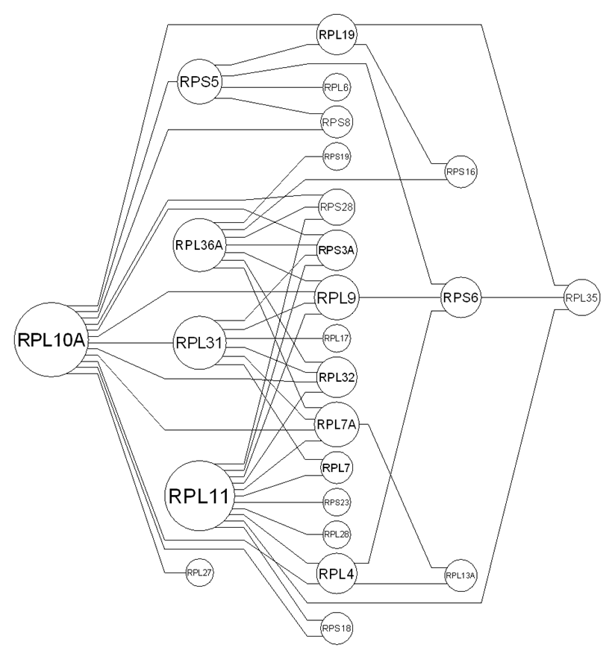

Figure 22. CML-specific network of the “KEGG Ribosome” gene set.

As the “KEGG Ribosome” annotation under-represented the CML-specific network of the NPM1-related genes, it is important to identify the lost connections and their involved RP genes. RPL18, RPL23, RPL34, RPS11, RPS24, RPS3, and RPS9 are the RP genes in “KEGG Ribosome” gene set that were not found in the CML-specific network. Differential expression analysis showed that these seven RP genes of the lost connections, except RPS9, were significantly under-expressed in CML (p<0.05).

The hub genes of “KEGG Ribosome” and their connections with NPM1 in CML-specific network implicate the essential role of NPM1 in regulating the ribosome biogenesis. Among the significantly associated gene set annotations in GeneSetDB (GO), NPM1 was found in “Ribonucleoprotein complex” (GO:0030529) that significantly over-represented conforming network (p=8.4×10-7) and under-represented opposing network (p=1.4×10-2).

Among the significantly associated gene set annotations in Reactome, NPM1 was found in “Disease” (REACT\_116125) where the CML-specific (p=5.3×10-7), normal-specific (p=2.6×10-13), and opposing (p=4.2×10-6) networks were under-represented and conforming network was over-represented (p=2.1×10-53). The CML-specific network of the “Disease” gene set is shown in Figure 23.

C:\1research\MISEA\miseaSQL\diffentialCoExpression\npm1\functionAnnotation\networkGraph\reactome\r9_cml.emf

Figure 23. CML-specific network of “Disease” gene set in Reactome.

1. Discussions

This work is the first endeavor to explore the co-expression levels of all possible gene pairs in neoplastic and normal states through the scatter plot, called co-expression galaxy. In the co-expression galaxy, each point represents a gene pair and its coordinates implicate the roles of the pair in the two states. It is important to partition the co-expression galaxy into regions where the gene pairs in the same region exhibit similar alterations in their direct or indirect interactions from normal to neoplastic state. To develop a partitioning approach, the distributions of co-expression levels, called co-expression structures, were examined with respect to the ability for characterizing and differentiating the normal and neoplastic states. The genome-wide difference in co-expression structures between CML and normal states provided a signature of the globally altered molecular mechanism as we found more strongly co-expressed pairs in the CML state than the normal state. The observed differential co-expression structure featured by a breakeven point suggests a threshold of co-expression level that optimally classifies the gene pairs into strongly and weakly co-expressed gene pairs. Such distribution-based classification approach explicitly outperformed the traditional pair-wise approach on a simulated gene expression dataset where the ground truth of the inter-gene associations was known.

The optimal threshold of co-expression level partitioned the co-expression galaxy into nine regions. The central region contained the weak co-expressed pairs. The other eight regions containing the strong co-expressed pairs include two conforming, two opposing, two neoplasm-specific and two normal-specific regions. Opposing regions contain gene pairs with correlations in opposite signs, covering gene pairs with differential co-expression. Differential co-expression analysis has been widely applied for identifying the altered molecular interaction processes, e.g. transcriptional regulation. Rhinn et al. performed differential co-expression correlation network analysis of the transcriptomic data in unaffected apolipoprotein E ε4 allele (APOE4) carriers and late-onset Alzheimer’s disease (LOAD) patients [48]. The analysis examined individually the gene pairs involving transcriptional regulation and pursued a set of candidate core mediators underlying the APOE4 associated molecular pathway in LOAD. In differential co-expression analysis, a critical alteration in co-expression level was required to support a single network connection. However, the differential co-expression analysis imposes a very stringent criterion on the correlation difference and ignores the functional modules of multiple genes without significant correlation difference but underlying the same molecular mechanisms. Such issue was addressed by Zhou et al. and 2nd-order expression analysis was proposed to construct regulatory network with transcriptional modules [49]. Therefore, the differential co-expression analysis is not able to detect the neoplasm-specific and normal-specific gene pairs whose connections are very active in one state but inactive in another. Further, the conforming co-expressed gene pairs represent network connections that are consistently maintained and functioning in both normal and neoplastic states. These rationales motivates us to investigate into the partitioning of the co-expression galaxy and the meanings of the corresponding gene networks in molecular mechanisms systemically altered in neoplasm.

It was proved that the difference in gene pair counts between neoplasm-specific and normal-specific regions is equivalent to the structural difference in co-expression and can be visualized through the asymmetry of co-expression galaxy over the identity line. The proof further justified the importance of neoplasm-specific and normal-specific gene pairs in uncovering the systemic alteration in co-expression and the underlying mechanism. In the genome-wide analysis of the real microarray data obtained from CML patients and healthy individuals, the normal-specific pairs were explicitly more than the CML-specific gene pairs. However, the observation was opposite when we focused on the connections between NPM1 and the genes along the BCR-ABL related pathway. The discordance of NPM1-centered co-expression patterns with the genome-wide co-expression structures supports the remarkable role of NPM1 as a stress sensor. More genes co-expressed with NPM1 in CML explained why NPM1 is over-sensitive in response to the oncogenic stress and thus promotes cell proliferation through excessive protein synthesis. The aberrant response of NPM1 in CML could be modulated through molecular target therapy if the mechanism of NPM1-mediated stress sensing and protein synthesis can be deciphered.

To uncover the NPM1-mediated molecular mechanism, the proposed structural gene network analysis was performed on 93 NPM1-related genes. In addition to the opposing gene connections, in which the differentially co-expressed gene pairs were widely studied, our analysis identified other important connections among these genes. We focused on the CML-specific and normal-specific whose connections are uniquely lost and established over one of the groups, and conforming co-expressed gene pairs whose connections are shared between the normal and CML groups. The identified differential structures exhibiting the discrepancy in connectivity and functionality between the CML-specific and normal-specific networks shed light on the impaired function of gene modules or the interrupted pathway signal transduction related to NPM1. In the co-expression analysis of the NPM1-related genes, significantly more strongly co-expressed pairs were found in the CML than the normal group. It is required to verify that the observation of such distinguishing co-expression pattern was incurred by the 93 NPM1-related genes but not by any 93 genes arbitrarily selected from the whole genome. It was shown in the randomization test that the CML-associated co-expression pattern was not observed by chance and was incurred by the NPM1-related genes.

The normal-specific network showed complete dissociation between NPM1 and RP genes. However, the CML-specific network indicated strong association of NPM1 with three RP genes, RPL10A, RPL31, and RPL36A, which acted as hubs of a big RP gene network. It implied that the NPM1 expression was over-coordinated with that of RP genes to expedite the ribosome maturation in CML state. Over-coordination may be the cause of the enhanced cell proliferation in CML. In normal state, only six RP genes were strongly co-expressed. The expression of the other RP genes may be under-coordinated. As NPM1 affects the ribosome assembly, the dissociation of NPM1 expression with RP genes sets these under-coordinated RP genes free for their translocation to nucleoplasm. RPL11 was found to be a hub of the CML-specific network but an under-coordinated RP gene in normal state. The free RPL11 released to nucleoplasm interacts with MDM2, leading to stabilization of p53 and inhibiting the cell proliferation [22].

Cell line experiment was performed to validate the inter-gene connections of CML-specific network inferred by co-expression analysis of microarray data. The gene expression profile of the K562 cell line was perturbed by applying resveratrol treatment as stimulus. It was found that NPM1 and the twenty-one genes predicted to be strongly co-expressed with NPM1 were all down-regulated upon the resveratrol treatment. The observed cellular response complied with the positive correlations between NPM1 and its strongly co-expressed genes identified by the proposed co-expression analysis. The silencing or knockout of NPM1 was not considered as a condition applied to the cell line because the identified connections are not directional and it is unknown whether the change in the NPM1 expression is the cause or the consequence in these 21 co-expression links. The validated connections facilitate the prediction and monitoring of NPM1-related molecular treatment response. To the best of our knowledge, NPM1 interacts with two heterogeneous nuclear ribonucleoproteins (hnRNPs), namely hnRNPU and hnRNPA1, to selectively affect mRNA processing [20]. According to the CML-specific network and the experimental validation results, we further identified the novel association between NPM1 and hnRNPM. Dery et al. showed that hnRNPM, hnRNPA1 and hnRNPL control the alternative splicing of pre-mRNA of carcinoembryonic antigen-related cell adhesion molecule-1 (CEACAM1) whose aberrant expression is implicated in carcinogenesis [50].

This work also developed a novel approach for performing the functional annotation of gene networks instead of gene items. The inter-gene connections were specifically annotated by the pair-based mapping onto the functional gene sets. Among the identified 47 annotations, the functional annotation “KEGG Ribosome” of CML-specific network further elucidates the above-mentioned coordination of RP genes. The under-expression of the highly connected RPL11 implies higher fidelity of ribosome assembly and fewer free RPL11, and thus promotes the cell proliferation. In those “KEGG Ribosome” connections lost in CML-specific network, most of the involved RP genes were under-expressed in CML, diminishing the release of free RPs. The over-representation of conforming network and under-representation of opposing network by “Ribonucleoprotein complex” further confirm the association of NPM1 with hnRNPs in both normal and CML states. It agrees with the findings of Maggi et al. that NPM1 forms complex with RPs and hnRNPs that may involve in the nuclear export of both the 40S and 60S ribosomal subunits [51]. The functional annotation “Disease” also includes NPM1 and RP genes whose connections were shown in the CML-specific network. In the annotation hierarchy of Reactome, “HIV Infection” is a branch of “Disease”. It was shown in Attila et al. that NPM1 affects the ribosome assembly through its relatively high affinity for HIV-1 Rev protein [52]. The high affinity property of NPM1 directs the nuclear import of HIV-1 Rev protein that contains sequence of nuclear localization signals (NLS). Such NLS sequence was used for synthesizing the Rev peptide that binds to NPM1 [53,54]. The binding of Rev peptide with NPM1 inhibits the translocation of NPM1 to cytoplasm. Thus, the Rev peptide is a potential CML treatment option that may retard the nuclear export of ribosomal subunits and the mRNA processing mediated by NPM1. In all, this research demonstrated the implementation of a novel structural co-expression network analysis and functional annotation platform in exploring the mechanism of CML and its potential NPM1-oriented treatment.

References

1. Ideker, T. and Sharan, R. (2008) Protein networks in disease. Genome Res. 18, 644-652.
2. Stuart, J.M., Segal, E., Koller, D., Kim, S.K. (2003) A gene-coexpression network for global discovery of conserved genetic modules. Science 302, 249-255.
3. Elo, L.L. et al. (2007) Systematic construction of gene coexpression networks with applications to human T helper cell differentiation process. Bioinformatics 23, 2096-2103.
4. Ideker, T. et al. (2002) Discovering regulatory and signalling circuits in molecular interaction networks. Bioinformatics 18 (Suppl. 1), S233-S240.
5. Fuller, T.F. et al. (2007) Weighted gene coexpression network analysis strategies applied to mouse weight. Mamm. Genome 18, 463-472.
6. Kostka, D. and Spang, R. (2004) Finding disease specific alterations in the co-expression of genes. Bioinformatics 20 Suppl. 1, i194-i199.
7. Mo, W.J., Fu X.P., Han, X.T. , Yang, G.Y., Zhang, J.G., Guo, F.H., Huang, Y., Mao, Y.M., Li, Y. and Xie, Y. (2009) A stochastic model for identifying differential gene pair co-expression patterns in prostate cancer progression. BMC Genomics 2009, 10:340.
8. Horvath, S. and Dong, J. (2008) Geometric interpretation of gene coexpression network analysis. PLoS Comput. Biol. 4, e1000117.
9. Lee, H.K. et al. (2004) Coexpression analysis of human genes across many microarray data sets. Genome Res. 14, 1085-1094.
10. Benjamini, Y. and Hochberg, Y. (1995) Controlling the false discovery rate – a practical and powerful approach to multiple testing. J. Roy. Stat. Soc. B 57, 289-300.
11. Storey, J.D. and Tibshirani, R. (2003) Statistical significance for genomewide studies. Proc. Natl. Acad. Sci. U. S. A. 100, 9440-9445.
12. Choi, Y. and Kendziorski, C. (2009) Statistical methods for gene set coexpression analysis. Bioinformatics 25, 2780-2786.
13. Hudson, N.J. et al. (2009) A differential wiring analysis of expression data correctly identifies the gene containing the causal mutation. PLoS Comput. Biol. 5, e1000382.
14. Nowell, P.C. and Hungerford, D.A. (1960) A minute chromosome in human chronic granulocitic leukemia. Science 32, 1497-1501.
15. Melo, J.V. and Barnes, D.J. (2007) Chronic myeloid leukaemia as a model of disease evolution in human cancer. Nat Rev Cancer 7, 441-453.
16. O'Brien, S.G., Guilhot, F., Larson, R.A., Gathmann, I., Baccarani, M., Cervantes, F., et al. (2003) Imatinib compared with interferon and low-dose cytarabine for newly diagnosed chronic-phase chronic myeloid leukemia. N Engl J Med 348, 994-1004.
17. Quintás-Cardama, A., Kantarjian, H.M., Cortes, J.E. (2009) Mechanisms of primary and secondary resistance to imatinib in chronic myeloid leukemia. Cancer Contr 16, 122-131.
18. Cilloni, D., Saglio, G. (2012) Molecular pathways: BCR-ABL. Clin Cancer Res. 18(4), 930-937.
19. Grisendi S, Mecucci C, Falini B, Pandolfi PP 2006. Nucleophosmin and cancer. Nat Rev Cancer 6493-6505.
20. Yao, Z., Duan, S., Hou, D., Wang, W., Wang, G., Liu, Y., Wen, L., Wu, M. (2010). B23 acts as a nucleolar stress sensor and promotes cell survival through its dynamic interaction with hnRNPU and hnRNPA1. Oncogene 29(12), 1821-1834.
21. Pelletier, C.L., Maggi, L.B.Jr., Brady, S.N., Scheidenhelm, D.K., Gutmann, D.H., Weber, J.D. (2007) TSC1 sets the rate of ribosome export and protein synthesis through nucleophosmin translation. Cancer Res. 67(4), 1609-1617.
22. Suzuki, A., Kogo, R., Kawahara, K., Sasaki, M., Nishio, M., Maehama, T., Sasaki, T., Mimori, K., Mori, M. (2012) A new PICTure of nucleolar stress. Cancer Sci. 103, 632-637.
23. Falini, B., Mecucci, C., Tiacci, E., et al. (2005) Cytoplasmic nucleophosmin in acute myelogenous leukemia with a normal karyotype. N Engl J Med 352, 254-266.
24. Villa-Cuesta, E., Boylan, J.M., Tatar, M., Gruppuso, P.A. (2011) Resveratrol Inhibits Protein Translation in Hepatic Cells. PLoS ONE 6(12), e29513.
25. Bishayee, A., Dhir, N. (2009) Resveratrol-mediated chemoprevention of diethylnitrosamine-initiated hepatocarcinogenesis: inhibition of cell proliferation and induction of apoptosis. Chem Biol Interact 179, 131-144.
26. Mortazavi, A., Williams, B.A., McCue, K., Schaeffer, L., Wold, B. (2008) Mapping and quantifying mammalian transcriptomes by RNA-Seq. Nat Methods 5(7):621-8.
27. Bernstein, S., Bernstein, R. (1999) Schaum’s Outline of Theory and Problems of Elements of Statistics II. McGraw-Hill, USA.
28. Voy, BH, et al. (2006) Extracting gene networks for low-dose radiation using graph theoretical algorithms. PLoS Comput. Biol., 2, e89.
29. Ricci, P.F. (2006) Environmental and health risk assessment and management: principles and practices; Springer: Dordrecht, The Netherlands; pp. 291-293.
30. Leon, S.J. (2009) Linear algebra with applications. Pearson; 8th edition.
31. Diaz-Blanco, E. et al. (2007) Molecular signature of CD34(+) hematopoietic stem and progenitor cells of patients with CML in chronic phase. Leukemia 21(3), 494-504. Epub 2007 Jan 25.
32. Brentani, H. et al. (2003) The generation and utilization of a cancer-oriented representation of the human transcriptome by using expressed sequence tags. Proc Natl Acad Sci U S A. 2003 Nov 11;100(23):13418-23.
33. Ramaswamy, S., Tamayo, P., Rifkin, R., Mukherjee, S., Yeang, C.H., Angelo, M., Ladd, C., Reich, M., Latulippe, E., Mesirov, J.P., Poggio, T., Gerald, W., Loda, M., Lander, E.S., Golub, T.R. (2001) Multiclass cancer diagnosis using tumor gene expression signatures. Proc Natl Acad Sci U S A. 2001 Dec 18;98(26):15149-54.
34. Subramanian, A., Tamayo, P., Mootha, V.K., Mukherjee, S., Ebert, B.L., Gillette, M.A., Paulovich, A., Pomeroy, S.L., Golub, T.R., Lander, E.S., Mesirov, J.P. (2005) Gene set enrichment analysis: a knowledge-based approach for interpreting genome-wide expression profiles. Proc Natl Acad Sci U S A. 2005 Oct 25;102(43):15545-50.
35. de la Fuente, A. (2010) From ‘differential expression’ to ‘differential networking’ - identification of dysfunctional regulatory networks in diseases. Trends Genet. 26(7), 326-333.
36. Osman, A.M., Bayoumi, H.M., Al-Harthi, S.E., Damanhouri, Z.A., Elshal, M.F. (2012) Modulation of doxorubicin cytotoxicity by resveratrol in a human breast cancer cell line. Cancer Cell Int. 12(1), 47.
37. Can, G., Cakir, Z., Kartal, M., Gunduz, U., Baran, Y. (2012) Apoptotic effects of resveratrol, a grape polyphenol, on imatinib-sensitive and resistant K562 chronic myeloid leukemia cells. Anticancer Res. 32(7), 2673-2678.
38. Araki, H., Knapp, C., Tsai, P., Print, C. (2012) GeneSetDB: a comprehensive metadatabase, statistical and visualisation framework for gene set analysis. FEBS Open Bio 2012, 2(2012):76-82.
39. Croft, D., O'Kelly, G., Wu, G., Haw, R., Gillespie, M., Matthews, L., Caudy, M., Garapati, P., Gopinath, G., Jassal, B., Jupe, S., Kalatskaya, I., Mahajan, S., May, B., Ndegwa, N., Schmidt, E., Shamovsky, V., Yung, C., Birney, E., Hermjakob, H., D'Eustachio, P., Stein, L. (2011) Reactome: a database of reactions, pathways and biological processes. Nucleic Acids Res. 2011 Jan;39(Database issue):D691-7.
40. Ashburner, M., Ball, C.A., Blake, J.A., Botstein, D., Butler, H., Cherry, J.M., Davis, A.P., Dolinski, K., Dwight, S.S., Eppig, J.T., Harris, M.A., Hill, D.P., Issel-Tarver, L., Kasarskis, A., Lewis, S., Matese, J.C., Richardson, J.E., Ringwald, M., Rubin, G.M., Sherlock, G. (2000) Gene ontology: tool for the unification of biology. The Gene Ontology Consortium. Nat Genet. 2000 May;25(1):25-9.
41. Ogata, H., Goto, S., Sato, K., Fujibuchi, W., Bono, H., Kanehisa, M. (1999) KEGG: Kyoto Encyclopedia of Genes and Genomes. Nucleic Acids Res. 1999 Jan 1;27(1):29-34.
42. Nam, D., Kim, S.Y. (2008) Gene-set approach for expression pattern analysis. Brief Bioinform. 2008 May;9(3):189-97.
43. Fisher, R.A. (1922) On the interpretation of χ2 from contingency tables, and the calculation of P. J Roy Statist Soc 1922, 85:87-94.
44. Agresti, A. (1992) A survey of exact inference for contingency tables. Statist. Sci. Volume 7, Number 1 (1992), 131-153.
45. Biddle, D.A., Morris, S.B. (2011) Using Lancaster's mid-P correction to the Fisher's exact test for adverse impact analyses. J Appl Psychol. 2011 Sep;96(5):956-65.
46. Upton, G.J. (1992) Fisher's Exact Test. Journal of the Royal Statistical Society. 155(3): 395-402.
47. Bonferroni, C.E. (1936) Teoria statistica delle classi e calcolo delle probabilità. Pubblicazioni del R Istituto Superiore di Scienze Economiche e Commerciali di Firenze 8, 3-62, 1936.
48. Rhinn, H., Fujita, R., Qiang, L., Cheng, R., Lee, J.H., Abeliovich, A. (2013) Integrative genomics identifies APOE ε4 effectors in Alzheimer’s disease, Nature. 2013 Aug 1;500(7460):45-50.
49. Zhou, X.J., Kao, M.C., Huang, H., Wong, A., Nunez-Iglesias, J., Primig, M., Aparicio, O.M., Finch, C.E., Morgan, T.E., Wong, W.H. (2005) Functional annotation and network reconstruction through cross-platform integration of microarray data. Nat Biotechnol. 2005 Feb;23(2):238-43.
50. Dery KJ, Gaur S, Gencheva M, Yen Y, Shively JE, Gaur RK. (2011) Mechanistic control of carcinoembryonic antigen-related cell adhesion molecule-1 (CEACAM1) splice isoforms by the heterogeneous nuclear ribonuclear proteins hnRNP L, hnRNP A1, and hnRNP M. J Biol Chem. 286(18). (doi: 10.1074/jbc.M110.204057)
51. Maggi Jr.L.B., Kuchenruether M, Dadey D.Y.A., Schwope R.M., Grisendi S., Townsend R.R., Pandolfi P.P., Weber J.D. (2008) Nucleophosmin Serves as a Rate-Limiting Nuclear Export Chaperone for the Mammalian Ribosome. Molecular and Cellular Biology 28(23), 7050–7065.
52. Szebeni A., Mehrotra B., Baumann A., Adam S.A., Wingfield P.T., Olson M.O.J. (1997) Nucleolar Protein B23 Stimulates Nuclear Import of the HIV-1 Rev Protein and NLS-Conjugated Albumin. Biochemistry 36, 3941-3949.
53. Chan, H. J., Weng, J. J., and Yung, B. Y. M. (2005) Nucleophosmin/B23-binding peptide inhibits tumor growth and up-regulates transcriptional activity of p53. Biochem. Biophys. Res. Commun. 333, 396–403.
54. Tran N.T.T., Wang T.H., Lin C.Y., Tsai Y.C., Lai C.H., Tai Y., Yung Y.M. (2011) Direct Synthesis of Rev Peptide-Conjugated Gold Nanoparticles and Their Application in Cancer Therapeutics. Bioconjugate Chem. 22, 1394–1401.

Table S1. Significantly associated functional annotations of Gene Ontology (at least one networks yielded Bonferroni adjusted *p*-value < 0.05).



Note:

1. The third column is the GO categories including 1) BP: biological process, 2) MF: molecular function, and 3) CC: cellular component.
2. *k* is the number of gene pairs of the network found in the gene set.
3. *ke* is the expected number of gene pairs found in the gene set.
4. FDR and Bonferroni adjusted *p*-value are highlighted if less than 0.05.
5. Gene sets are sorted according to their *p*-values to CML-specific network.

Table S2. Significantly associated functional annotations in Reactome pathway (at least one networks yielded Bonferroni adjusted *p*-value < 0.05).



Note:

1. *k* is the number of gene pairs of the network found in the gene set.
2. *ke* is the expected number of gene pairs found in the gene set.
3. FDR and Bonferroni adjusted *p*-value are highlighted if less than 0.05.
4. Gene sets are sorted according to their *p*-values to CML-specific network.

Table S3. Significantly associated functional annotations in KEGG pathways (at least one networks yielded Bonferroni adjusted *p*-value < 0.05).

Note:

1. *k* is the number of gene pairs of the network found in the gene set.
2. *ke* is the expected number of gene pairs found in the gene set.
3. FDR and Bonferroni adjusted *p*-value are highlighted if less than 0.05.
4. Gene sets are sorted according to their *p*-values to CML-specific network.